#

he Official Publication of ALOA ^^’’international Association of Security Professionals

**ictober 2003**

**Crime**

**Prevention**

**“United for a Stronger America:**

**A Safe Workplace is Everybody’s Business”**

*\*#******i'******it***2.[)IQI,p 203* Breck H. Camp CML POBox47070 Atlanta GA 30362-0070

liillilliiiiilliilliiiililllmlliiiliiillliiiliiillliiinlitl

Plus:

Electronic Access Control Tools That Pay for Themselves, Cycle Chronicles, Part 1, Taking the Pony Express to No Man's Land, The Early Stages of ALOA's New Shop Certification Program, and more!

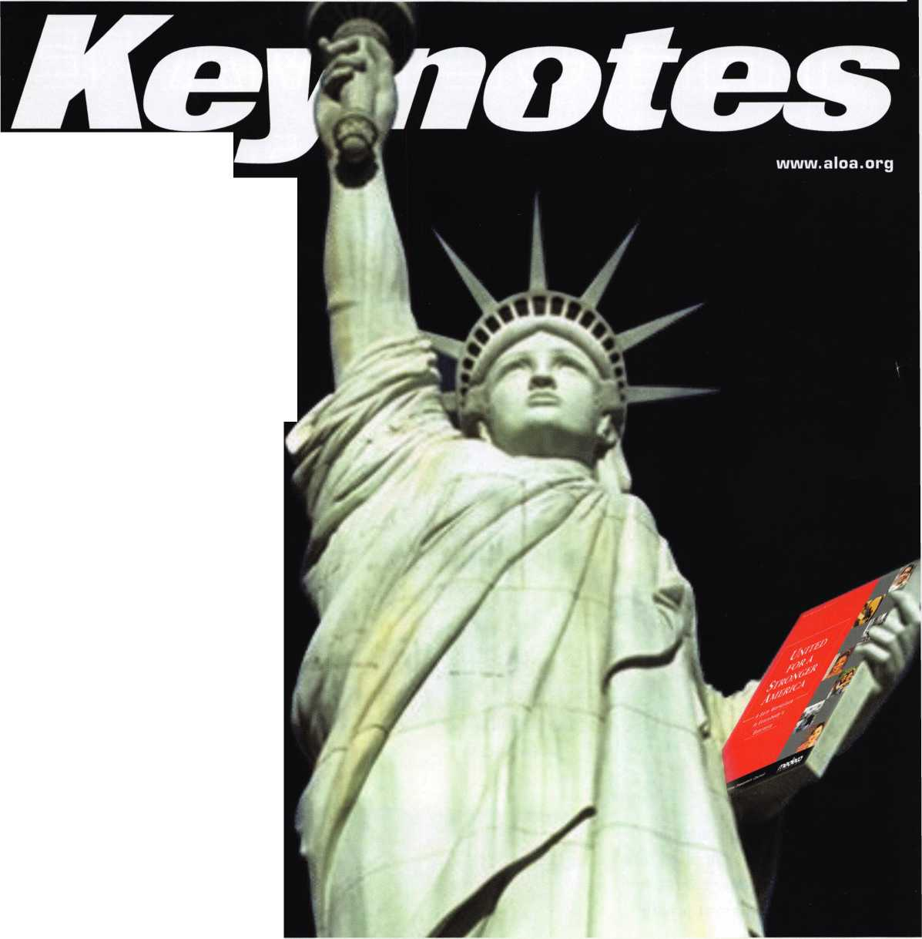

nnr.BC AMD WAR DWARF FUNDAMENTALS

**ELF-STUDY GUIDEBOOK**

Ruailable as single  
modules (one CD and  
guidebook) or the full  
set (three CDs and  
three guidebooks).

Seruer uersions are  
also auailable!

**Self-Study Course**

RLOfl

SPECIRL

**Get the award-winning  
*Fundamentals of architecture  
Doors and Hardware Self-Study  
Course* at a great price!**

*

FUNDAMENTALS OF:

The ultimate training tool for locksmiths... **Nolu** there is a complete in-house training program auailable! Order the **Fundamentals of Architectural Doors and Hardware Self**

**Study Course** three CD/guidebook series.

**To** order, call **(800)532-2562** or LUiuiu.aloa.org

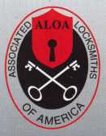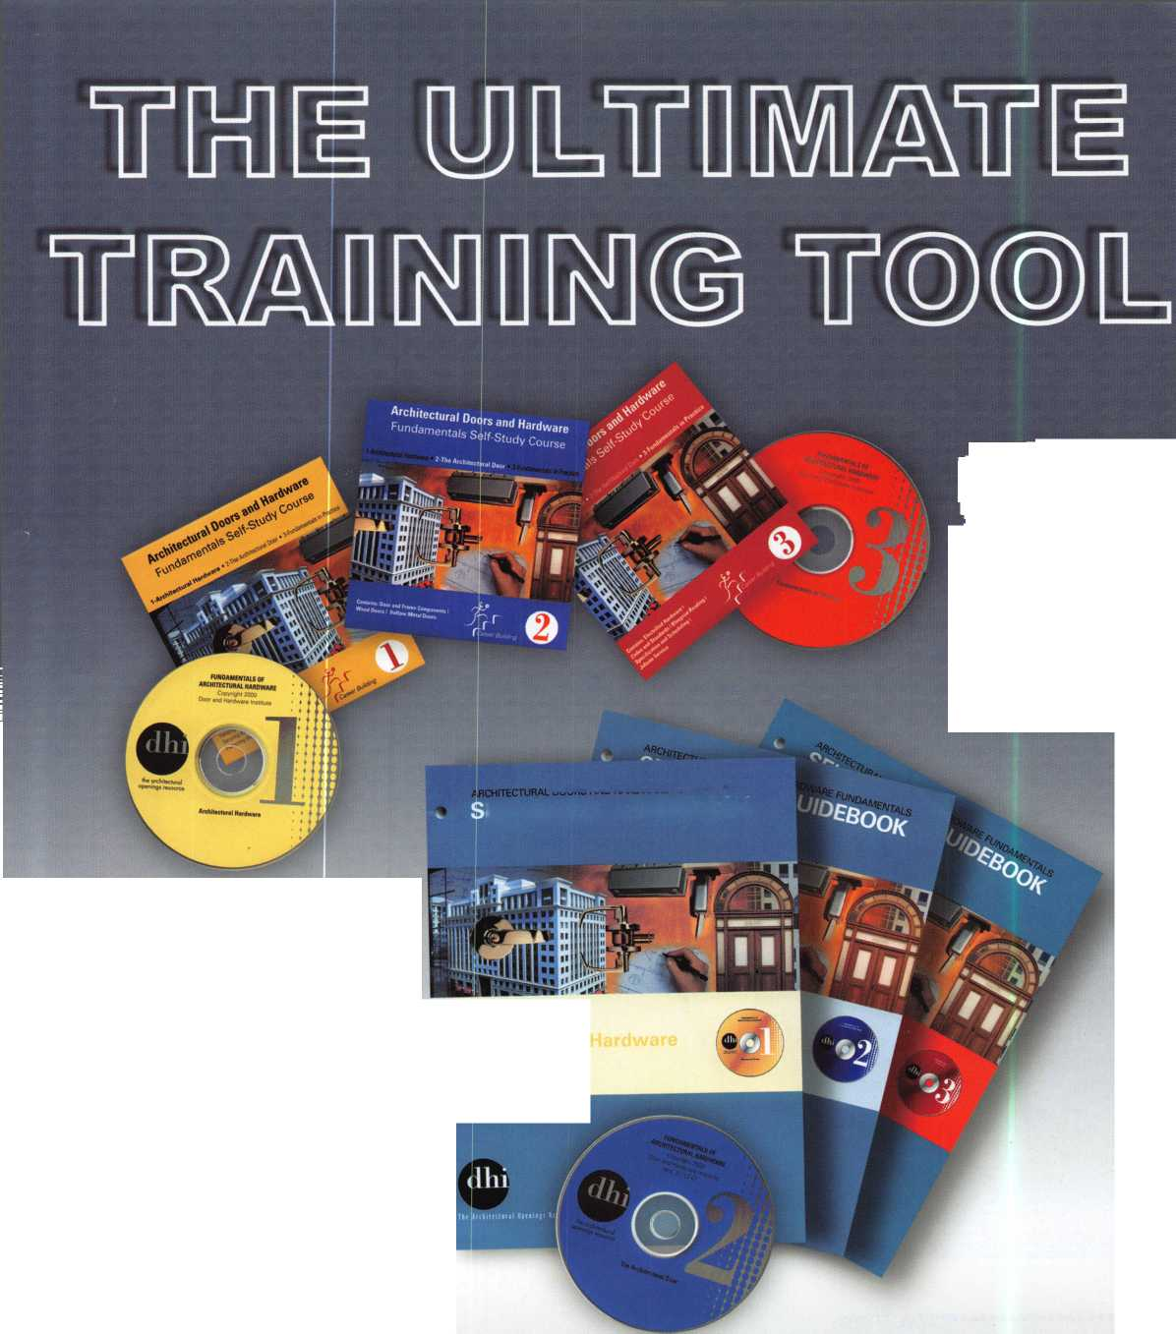

Proue Vou’re a Pro ’04

HLOfl Rewards Its Members HGRINM

The RLOR Membership Campaign for 2004 features

more member benefits than we’ue euer offered

before. LUe’re stuffing members full of great gifts!!

If you renew your commitment to your industry  
and help support RLOR, we will offer FREE mem-  
bership dues to RNV CURRENT MEMBER who  
recruits one new member on or before January  
1, 2004.

RLOH is excited about the uast legislatiue challenges that lie ahead,  
and we re waiting for our members to let us after those groups that

are aiming to legislate locksmiths out of business, one bad bill at a  
time. Were readg to do our part for the prosperitg of this industrg.

Please help yourselues bg doing your part this year. Proue you’re a pro by  
sticking with HLOR in 2004. You will be rewarded for it mang times ouer.

Note: The RLOR Board of Directors has enacted a $25 Legislatiue assessment to the regular RLOR dues for all actiue members in the USA (and territories) in 2004. If you Hue in the United States or its territories, you must pay the assessment to maintain your membership. The assessment will be payable during this year's dues billing, which mailed on Oct. 1, 2005. Rs directed specifically in writing by the RLOR Board, the proceeds from this assessment will be auailable for use ONLY in RLOR's legislatiue efforts.

**Rll members mho renew on or before January 1, 2004, will receiue:**

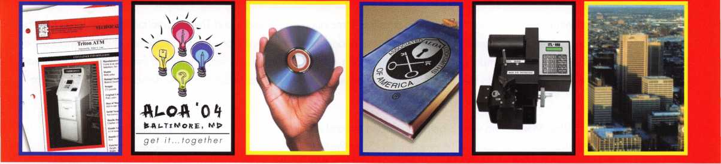

R complimentary set  
of 2 safe technical  
bulletins

Up to $300 sauings  
on RLOR 2004  
Conuention  
registration

R complimentary  
copy of the RLOR  
Membership  
Directory (CD)

R $10 discount for any purchase from the RLOR Bookstore

Rutomatic entry into  
a drawing for a  
brand new ITL-950C  
key code machine

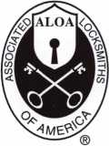

Associated Locksmiths of Rmerica

3003 Liue Oak Street • Dallas, Texas 75204-6186

800-572-RLOR (2562) • **LUUMii.aloa.org**

Rutomatic entry into  
a drawing for a free  
RLOR 2004  
Conuention Full  
Registration  
Package (including  
hotel)



presidential  
p e n n i n g s

By now, all of the active ALOA members in the United States should have received a notice that there will  
be a $25 Legislative Assessment attached to the dues for 2004 (and will continue in 2005 and 2006 as  
well). This was a unanimous decision of the ALOA Board of Directors at the 2003 Convention. Can you  
imagine how hard it is to get 17 different personalities from around the world to think the same way? It is  
that important!

For years, contributions to the Legislative Action Network have been on a voluntary basis. Now, pending  
Federal legislation on several issues that directly affect locksmiths, it is necessary for us to collect funds to

support legislation that is favorable to us, and to combat legislation that attempts to prevent us from doing

what we are capable of doing. Please be aware that the money from this assessment can be used for legislative purposes ONLY.

That is, to hire lobbyists, to send our legislative affairs manager to meet with representatives involved with legislation, to aid our affili­ates and local chapters in dealing with legislation on the state level, etc. In the past, these monies have come from the general budg­et and put a strain on providing other services that would benefit the membership.

There is likely to be a negative reaction and some fallout in membership due to this assessment, even though our dues are still among the lowest of any trade organization in the world. There will be members who will say that legislation doesn't affect them. But, unless you will be retiring in the next year, I guarantee that you will be affected sooner rather than later. Before past Legislative Affairs man­ager Tim McMullen left, he challenged the Board of Directors to lead by example and contribute $1,000 each (or whatever we could reasonably afford) to the Legislative Action Network. The vast majority of us did! This should indicate to those that are consider­ing dropping out that we as, an association, are fighting for our industry rights! Who else will fight this battle?

We are a fragmented industry! This is a time when we need to rally as an industry and come together as a united front. ALOA is pro­viding tremendous incentives for its members to recruit other members and increase our strength. Talk to the locksmiths in your area and encourage them to join.

Congratulations this month to the Louisiana-Mississippi Locksmiths Association on 35 years and The Association of Ontario Locksmiths (TAOL) on 30 years of service to the locksmith community. That's a long time, and a testimony to the dedication of the members and officers of those associations. It is so important to cultivate the young people in our industry into continuing the traditions of our trade and not relying on the same people to do the same jobs, year after year. These local associations have demonstrated the ability to do this.

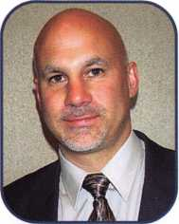

October is Crime Prevention Month, and who is better equipped to combat crime than the local locksmith? The Pacific Locksmith Association was successful in having October 16 proclaimed "State Professional Locksmith Day" by the Governors of both Washington and Oregon! That is the kind of publicity that we need in informing the general public that that is what we exist for... crime prevention.

Regards,

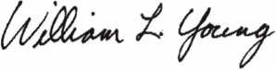

William L. Young, CML

Keynotes • October 2003

**Fastening Solutions**

4; ^

^IfSililliiPil

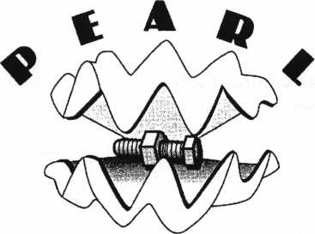

TECHNICAL SATES, INC.

**Pearl Technical Sales**

***featuring sex bolt solutions from***

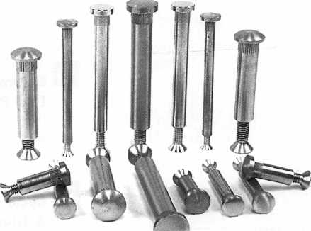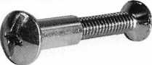

n



Sex Bolt Hardware and Fasteners - In stock for immediate shipment.

• Sex Bolts - Standard and Custom Sizes • Custom Service

* Sex Bolt Assortment Kits
* Barrel Bolts
* Binding Posts
* Connecting Bolts
* 50 Piece Minimum custom order
* Quick TurnAround
* CNC manufactured, Top Quality
* Brass, Stainless Steel, and Steel materials
* Architectural finishes

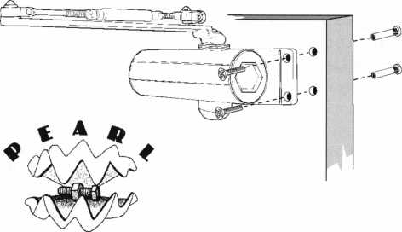

TECHNICAL I ALES, INC.

17Timbercrest Lane _ _ . __ _ _ . __ _ _ _ , __ . _ _ __

south setauket, ny 11720 Phon©i 631 "698*7173 • **Fgxi 631"736"5467**

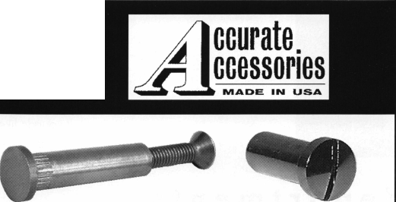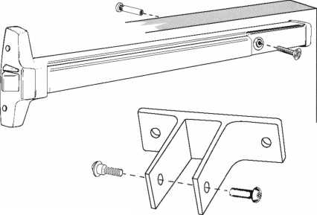

f e

u

r

e

s

a

t

CRIME PREVENTION

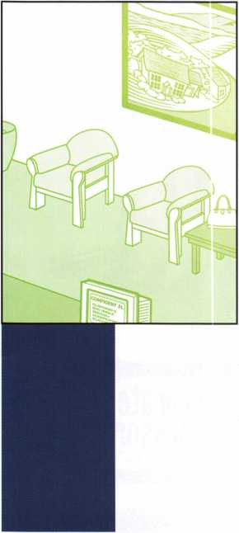

**departments**

Executive 5

Applicants 6

Calendar 8

Core 10

Legislative Update 38

Classifieds 40

12

United for a Stronger America:

A Safe Workplace is Everybody's Business ByAnnMcCrady,cpL Medeco and the National Crime Prevention Council have partnered to create a toolkit of materials to support the example above. This is the United for a Stronger America - A Safe Workplace is Everybody's Business initiative.

**16**

Electronic Access Control Tools

That Pay for Themselves **By Greg perry, cm, cps**

This month, let's explore some of the tools available to the access control technician. This is a list of the tools I use, along with a couple I don't own, but would like to own.

**20**

Cycle Chronicles, Part 1:

A Triumph in Every Way ByRayD'Adam0,cML

The owner of this 1995 Triumph Daytona 1 200 (Photo #1) bought it at an auction. He then purchased 2 Triumph original key blanks off the Internet and took everything to a locksmith. After 3 days and having trouble completing the work, the locksmith suggested taking the bike to us.



Taking the Pony Express to No Man's Land:

Crazy Combo (2-3-11?) spells "headache" By Greg Perry, CML, CPS It sounds like a date some time in the future; it can't possibly be a safe combo. Or can it? The call came in via our call tech, "How much to open a gun safe on a Sunday that's 70 miles away?" I called the customer; he's 81 years old, swears the combo he's been using is 2-3-1 1 and he wants in his safe now!

**32**

The Early Stages of ALOA's New

Shop Certification Program ByHansMejishedeCML

As the largest locksmith association in the world, ALOA has a standing obliga­tion to try to better the image of the locksmith. What is influencing our public image? Two of the major factors are our physical appearance and our knowl­edge level. How do our shops look? How do we dress? Do we have the right answers? Do we know most of the new technology? Do we give our customers quality work for a fair price?

Associate

Members 42

Back Page 44

**34**

D&D Technologies Adds High-Security Door and Gate Locks to

**Gate Hardware Lines** By Maureen Williams, Special to Keynotes

To meet the growing demand for high-security gate and door hardware, espe­cially for commercial applications, D&D Technologies has introduced a new line of architectural stainless steel locks for gates and doors, the FortE(tm) line. D&D Technologies has been well established in the fencing industry for over a decade, with its gate hardware being used OEM or distributed by virtually every major fencing company in the U.S.

V i s

t

our website at [www.aloa.org](http://www.aloa.org)

**executive**

Volume 49, Issue 9

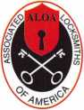

Additional contact information for the ALOA Board and most Keynotes authors is  
available through "Locksmith Search'" on the ALOA Web site- [www.aloa.org](http://www.aloa.org) or by  
contacting the ALOA office at 3003 Live Oak Street; Dallas, TX 75204; (800)532-2562;  
FAX (214)827-1810; e-mail [aloa@aloa.org](mailto:aloa@aloa.org).

|  |  |
| --- | --- |
| Editor  Jim DeSimone | [editor@aloa.org](mailto:editor@aloa.org) |
| Technical Editor  David Lowell, CML, CMST .... | [david@aloa.org](mailto:david@aloa.org) |
| Editorial Advisor  John D. Cannon, CML | [jdcannon@worldnet.att.net](mailto:jdcannon@worldnet.att.net) |
| Art Director  Betty Henderson | [betty@aloa.org](mailto:betty@aloa.org) |
| Advertising Sales  Kim Hammond | voice: 817-645-6778  Fax: 817-645-7599 e-mail: [adsales@aloa.org](mailto:adsales@aloa.org) |
| Executive Director  Charles W. Gibson, Jr., CAE | [charlie@aloa.org](mailto:charlie@aloa.org) |
| Convention & Meetings Manager  Jo Anne Mims [joanne@aloa.org](mailto:joanne@aloa.org) | |

PRP/Education Manager

David Lowell, CML, CMST [david@aloa.org](mailto:david@aloa.org)

Operations/Membership Manager

Mary May [mary@aloa.org](mailto:mary@aloa.org)

Government Relations Manager

|  |  |
| --- | --- |
| Paul Kanitra | [paul@aloa.org](mailto:paul@aloa.org) |
| IT Operations Manager  Greg Jackson | [greg@aloa.org](mailto:greg@aloa.org) |
| Comptroller | Kathy J. Romo |
| Membership Coordinator | Shelly Jett |
| Convention & Meetings Assistant Karen Lyons | |
| PRP/Education Coordinator | ....Esperanza Rodriguez |
| Accounting Coordinator | Stephanie Brothers |
| Mail Room Coordinator | Kevin Wesley |
| Receptionist | Bryan Dease |

Contributors

Jerome Andrews, CML  
Paul Chandler, CRL  
Claire Cohen, CML  
Brian Costley, CML, CMST  
Eric Costley, CRL

Ray D'Adamo, CML Sal Dulcamaro, CML Billy Edwards, CML Dan Graffeo, CRL,CMST Jim Hancock, CRL

A.J. Hoffman, CML Jeff Nunberg, CML, CMST Randy Simpson, CML Robert Stafford, CML Dave Thielen, CML

Greg Perry, CML,CPS Tom Seroogy Charles Stephenson, CPS Dennis Watanabe, CML, CMST

**Mission Statement:** The Associated Locksmiths of America, Inc. is dedicated to enhancing the professionalism, education and ethics among locksmiths and those in related sectors of the physical security industry. With approximately 10,000 members in the United States, Canada and the freeworld, ALOA is poised to help members obtain the knowledge, the strength, and the confidence to perform their role in the physical security field with pride and dignity. But it is only through active involvement and participation that ALOA can fully achieve its potential—and can help members to achieve theirs.

**Policies: Keynotes**® is the official publication of the Associated Locksmiths of America, Inc. (ALOA). **Keynotes**® acts as a moderator without approving, disapproving, or guaranteeing the validity or accuracy of any data, claim, or opinion appearing under a byline or obtained or quoted from an acknowl­edged source. The opinions expressed by the authors do not necessarily reflect the official views of ALOA. Also, appearance of advertisements and new products or service information does not constitute an endorsement of products or services featured by the Association. The Association does not accept responsibility for the inaccuracy of any data, claim, or opinion appearing in this publication, due to typographical errors on the part of the authors, Association staff or its agents.

**Editor's Note:** This publication is designed to provide accurate and authoritative information in regard to the subject matter covered. It is provided and disseminated with the understanding that the publisher is not engaged in rendering legal or other professional services. If legal advice and other expert assistance is required, the services of a competent professional should be sought.

**Authors' Payment:** Payment for eligible submissions to Keynotes will be based on the following criteria: topic, time spent and past contributions. Authors who regularly submit to **Keynotes**® are generally paid a higher rate. The latter is especially true of authors who write to fit specific editorial needs and submit said copy by **Keynotes**® deadlines. As a general guideline: Average payment for a 750 word, business or 'light' technical article would be $200. Payment for a 1500 word article involving significantly higher time and research efforts would be $400.

Payment will not be offered for articles submitted by ALOA employees or members of the ALOA Board of Directors (unless material is of a technical nature), nor for articles submitted by a company that promote that company's products or services. ALOA reserves the right not to pay for articles sub­mitted by an individual(s) that promote a particular company's products or services.

**Disclaimer:** The Associated Locksmiths of America, Inc., (ALOA), reserves the right to refuse any article for any reason. Additionally, ALOA reserves the right to edit, amend or modify any article submitted for publication in order to preserve technical accuracy, clarity, fairness or grammatical cor­rectness. ALOA will make the best efforts to notify the author of any changes. The extent of ALOA's liability for any article or information contained therein will be a notice of correction or retraction in the next possible issue.

**Keynotes®** (ISSN 0277 0792) is published monthly except for the combined June/July issue by The Associated Locksmiths of America, Inc., 3003 Live Oak St., Dallas, TX 75204-6186. Telephone: (214) 827-1701; FAX (214) 827-1810; e-mail [aloa@aloa.org](mailto:aloa@aloa.org). Subscription rates for members—$15.00 per year. Business class postage paid at Dallas, Texas. POSTMASTER: Send address changes to: Keynotes, 3003 Live Oak St., Dallas, TX 75204-6186. © Copyright 2003, All rights reserved. No part of the contents may be reproduced or reprinted in any form without prior written permission of the publisher.

President

William L. Young, CML  
[president@aloa.org](mailto:president@aloa.org)

Secretary

John D. Cannon, CML  
(703) 960-6413  
[secretary@aloa.org](mailto:secretary@aloa.org)

Directors, Northeast

Robert E. Mock  
(856) 863-0710  
nedirector@aioa .org

Peter Sarailian, CRL  
(973)890-9797  
[nedirector@aloa.org](mailto:nedirector@aloa.org)

William L. Young, CML  
(610)647-5042  
[nedirector@aloa.org](mailto:nedirector@aloa.org)

Directors, Southeast

Tom Gillingham, Jr., CML, CPS  
(615)264-0717  
[sedirector@aloa.org](mailto:sedirector@aloa.org)

Ken Kupferman, CPL  
(813)961-5784  
[sedirector@aloa.org](mailto:sedirector@aloa.org)

Directors, North Central

Mark E. Blum, CML, CPS  
(517) 482-5809  
[ncdirector@aloa.org](mailto:ncdirector@aloa.org)

John Soderland, CML, CMST  
(414) 327-5625  
[prolock@aloa.com](mailto:prolock@aloa.com)

Director, South Central

CD Lipscomb, CML, CPS  
(903)874-3522  
scdi rector@aloa. org

Directors, Southwest

Gordon R. Racine, CML  
(719) 384-4707  
[swdirector@aloa.org](mailto:swdirector@aloa.org)

Julie McCluney, CRL  
(714) 636-5652  
s wd i rector@aloa. org

Director, Northwest

Scott L. Henke, CPL, CPS  
(907) 248-3785  
[nwdirector@aloa.org](mailto:nwdirector@aloa.org)

Director, European

Hans Mejlshede, CML  
(453)539-3939  
[eurdirector@aloa.org](mailto:eurdirector@aloa.org)

Director, Asian

JoeJ. Lee, CRL  
(215)289-2404  
[asigndirector@aloa.org](mailto:asigndirector@aloa.org)

Director, Associate

Paul M. Justen  
(800)333-6953  
asdirector@aloa. org

Trustees

trustees@aloa. org

Randy Simpson, CML  
(281)240-5959

John j. Greenan, CML, CPS  
(773) 486.2030

Dallas Brooks  
(334) 826-8990

Past Presidents

2001 -2002 Randy Simpson, CML 1999-2001 John Greenan, CML, CPS 1997-1999 Dallas C. Brooks 1995-1997 David Lowell, CML, CMST 1993-1995 Breck Camp, CML 1991-1993 Henry Printz, CML 1989-1991 Evelyn Wersonick, CML, CPS 1987-1989 Leonard Passarello, CPL 1985-1987 Joe Jackman, CML 1983-1985 Stanley Haney, CPL 1981-1983 Louis LaGreco, CPL 1979-1981 John Kerr, RL 1977-1979 Clifford Cox, CML 1974-1977 Charles Hetherington 1972-1974 Gene Laughridge 1970-1972 William Dutcher, RL 1968-1970 Constant Maffey, RL 1966-1968 Harold Edelstein, RL 1964-1966 William Meacham 1962-1964 Robert Rackliffe, CPL : 1960-1962 Edwin Toepfer, RL

1956-1960 Ernest Johannesen

Keynotes • October 2003

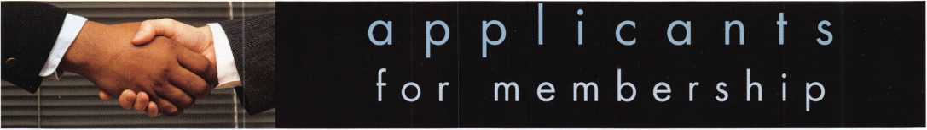

AK

Anchorage

Fred R. Olin

AL

Decatur

William R. Smith

Sponsor: Dulin Sherman CPL Huntsville

Jerry A. Sanderson

New Market

Ken Harris

AZ

Apache Junction

Wayne Barber Judy Barber

Bullhead City

Jeff Jochens

Sponsor: Ed Dyer

Steven Dean

Chandler

Aaron Williams Lindella Nixon Rich Panek

Flagstaff

Victor Varela

Lake Havasu City

Anthony L. Profera

Mesa

Larry Gilbert Kenneth E. Davis

Payson

Ken Davis

Phoenix

Wayne R. Stuart

Sponsor: Alan N. Anderson

Shannon L. Powell Charles Eastwood

Sponsor: Mark I. Kessman CRL

Brad Day

Sponsor: David M. Lowell CML, CMST

George Alegria Rita Lucero Ronnie King Travis L. Gearhart Glen D. Dwiggins Donald W. Wall Ruthie Stewart Jeff Stout Al Covarrubias Jerry Collins Edward Williams Lynn Hartman Todd Hogan Prescott Ira Stedman Prescott Valley Robert L. Bennett Thad Schotterback Tempe Eric Kaehr Kevin Amsler

Tucson

Edward J. Martori Danny Silver Colin L. Smith Jr Raymond E. Armijo

Youngtown

Wesley Womack

Sponsor: William Lee CRL Yuma

John Mirales

CA

Alhambra

William Van Chau Dai Van

Anaheim

Robert Lussier

Sponsor: Kenneth R. Lussier Sr, CPL

Bill Power Carlos Ponce Beto Malagon Evan Liftman Evan Liftman Arleta

Jacque Dean

Bakersfield

Neil W. Messick John Cleveland

Berkeley

Joseph M. Best Daniel E. Valdez Leonard J. Vasaure Jane Barbarow Efren G. Palabrica Marc Goldman Burbank

Tigran Aghadjamian

Canoga Park

Robert F. Webster

Canton Country

Steve Bench

Canyon Country

Alan Prager

Carson

L. C. Bishop

Cathedral City

Marc C. Jutras

Sponsor: Bruce S. Nemec CML

Richard Ferreria Eric Deyo Thomas Vizcarra

Cerritos

Rufino Aquino

Concord

Kara Wood

Costa Mesa

James Wilburn Micah Daniels Tosh H. Sugiyama

Covina

Carl Rainone Richard Lee Todd Faro

Culver City

Cori Allen

El Cajon

Anthony A. Hodge Steve Bastion Ryan M. McCormick

Fallbrook

Thomas Keehan

Fontana

Harold W. Harmon Sr Richard Harger

Fremont

Robert W. Van Zee

Sponsor: Steven M. Goldstein

Gordon Kuo

Fresno

Ernest J. Nan William Kimble Garden Grove Pensri Minnella John Yun Julio De La Rocha Hung Tran Gardena Steve Ra Gerdena

Anglea Mandic

Harbor City

Clyde Akers Hayward Bruce Sedley Issi Ayesh Chris Carlquist Healdsburg Jesse Suazo Hemet

Daniel Espey

Hollister

Ed Ortiz

Huntington Beach

Vera Collins

Pat Collins

Huntington Park

lanacid Alcaraz

Imperial Beach

Larry Block

Inglewood

Jorge Quinones

Irvine

**Gregory J. Adams** Sponsor: David Delgadillo

Shu Din Yu Puo-An Wu Fu Puo Hon Wu Fu Joe Williams Jesse Szynal Pat Baptist La Jolla

Carl Marcuzzi La Puente

Rick Chang Ted Chang

Li-Nai Lee

Judy Wei

Lakewood

James Marshall

Lancaster

Rodrigo A. Garcia Sid Fromberg Loma Linda Kenneth Bielas Long Beach Rene' I. Lopez Efrain Barajas Lynn Van Hazelen Rich Dorame Rod Chow Los Angeles Jerry Rios Pedro Morales Charles Cooper Bernard Poulin Meir Harison Jim Coy Gilbert Zavala Al Corbi Leo Krupitski Malibu

Jacob Ginion

Manhattan Beach

Zee Kohen

Menlo Park

Paul Boling

Mission Viejo

Randy Johnson

Modesto

Jack Khajadourian Morgan Hill Dick Green

Mountain View

John W. Waters

Murrieta

Dwayne E. Green

Newark

Rick Patterson

North Highlands

Richard J. Brooks William Sproul

Ontario

Joseph S. Horn Jacob Horn

Oxnard

Bill Wessel Clinton Cole

Pacheco

Elijah M. Mansker Pacoima Mike Salazar KB Brunston Clyde Smith Jeffrey Davis Thaddius B. Carter Palmdale Rod Oden Jorge Moran Luz Moran

Francisco Guzman Palo Alto Chris Guarino Jake Gonzalves

Paradise

Bruce A. Wahner Paramount Steve Halls Julianna Lorenz Pasadena Joe Pardee Janet Clark Paso Robles Joe Barclay Ted Hunter Pittsburg

Dennis G. Barlow

Pleasanton

Ronald Boxman

Porterville

Jason J. Carter

Sponsor: Glen A. Culver Quartz Hill

Mark Silver

Rancho Santa Margar

Szabo Geza

Redlands

Juan D. Basols

Redwood City

Eric Olsen

Reed ley

Santiago Gutierrez Santos Maldonado Norma Otero Reseda Ginon Noel Saro Markarian Rialto

George Meyer Christine Moore Shelly Moore-Meyer Mike Meyer Riverside Gene Slife David Muniz

Sponsor: William T. Straub CML

Lyndsey R. Reynolds Megan Clyde Carole Bernard Kelly Glover Ron Jones David O'Connel Colin Gilbert Michael Moreno Gerald Medel Salinas Brian Giles San Bernardino Steve Baker David Schnieder John Burnett San Clemente John Sweitzer

These applicants are scheduled for clearance as members of ALOA. The names are published for member review and comment within 30 days of this Keynotes issue date,  
respectively, to ensure applicants meet standards of ALOA's Code of Ethics. Protests, if any, should be addressed to the Membership Department and must be signed. Active  
Membership applicants (a) have worked in the industry two or more years. Allied Membership (AL) applicants are not locksmiths, but work in a security-related field.

Apprentice Membership (AP) applicants have worked in the industry less than two years.

Keynotes • October 2003

**San Dieflo**

Jason Wimp Donna Wiles Alex Feldman Rick Middlested Stuart Robertson Sergio Rugama Daniel Russell San Dimas Tom Yen **San Francisco** William Whitley Jeffrey Chin Bob Thompson LantzBen **San Gabriel** Sabino Cici **San Jose** Jason Lucas Pete Fuzere John D. Thompson Dung Thach Robert C. Vong Cathi Vong Quay Vong Gary Hane Alex Penano Daniel Mangogig **San Leandro**

Joan Roberts

**San Marino**

Alan Ying Michhael Kimball James Weng

**San Pedro**

David A. Garside RL Georgette Lowery Patrick Gamble Frank Bennett Kevin Mays **Sanfa Barbara** Lee Dobbs **Santa Rosa** Dan P. Weinstein **Santee**

Relio J. Cabrerd

**Seaside**

Janies B. Wilson

**Simi Valley**

Tony Costanzo

**Studio City**

Rkk Pistone

**Sunnyvale**

Michael Bell

**Sylmar**

Tavo Fernandez **Temecula** Craig Boswell Ryan Boswell Curtis Boswell Tyler Maseline **Temple City** Peter Ni **Thousand Oaks** Chris Clark Sid Rehka

Michael J. Kalvelage

**Torrance**

Matt Macdonald Dan Colburn

**Tustin**

Scott Sussman Siena Capps

**Twentynine Palms**

Mike Ernst Lisa Dan

**Upland**

Richard T. Kaplan

**Valencia**

David Middleton **Van Nuys** Billy Carmen Steven S. Cohen Janies Sully Ryan Rycerz Richie Robles Jeff Ross **Venice**

Sandy Palmer

**Victorville**

Kris Tatarian

**Visalia**

Cathy Jackson

**Vista**

James Kellogg Jr

**Walnut**

David Chen

**Walnut Creek**

Pete Rossiter

**Watsonville**

Samuel Barba

**West Hollywood**

Yossi Bouzaglo

Sponsor: David A. Williams

Morrif Alpert

**Whittier**

Shawn L Lafferty

Sponsor: Phillip E. Mossey **Winnetka**

Richard Blekier

**Woodland Hills**

Robert K. Doros

**Yucaipa**

Debbie Miner



Benny Benoit

**Lafayette**

Philip Wright

**Northglenn**

Dennis K. Harmon

**Peyton**

James Robertson

**Pueblo**

Thomas Clementi

**Bristol**

John L Schum

Koleen McCauley

**West Haven**

Al Leites

**Washington**

YusufS. Abdullah

**Ft Myers**

George M. Klein

Jacksonville

David McLean

**Kissimmee**

Tom McMahon

Lantana

Patrick Edwards

**Miami**

Robert L Arce Daniel Arce Robert Grant

Sponsor: William J. Wickward CML

Danny Pelaez Jorge Martinez

**Naples**

John L Lee

Sponsor: William C. Boughman **Orlando**

Jack Wincey

**Pace**

Mark C. Gaydosh

Sponsor: Russell D. Turner CRL

**Panama City Beach**

Larry Frazee

Sponsor: Dana L. Johnson CML

**Plant City**

Steven S. Wyman

Sponsor: Norman T. Ritz CRL

**Satellite Beach**

Wayne Wilkerson

**Tampa**

Gamal Farag

Sponsor: Earl S. Thomas



Chris Cartmell

Sponsor: Freddie P. Smith

CPL

Atlanta

Timothy Ivey

Sponsor: Tony L Pursley CRL

**Decatur**

Marvin L Beasley

Sponsor: Kevin R. Wilson CML, CPS **Dunwoody**

Kristin Wolford

**Ft. Stewart**

Jonathan Muhammad

**Marietta**

John Griff

**Statesboro**

Bryan K. Lowe

Sponsor: Horace A. Mixon **Winder**

Arthur J. Maddalena

Sponsor: Kevin R. Wilson CML, CPS



Ken Sengbounouvong

Sponsor: Tomiko Salz CPL

Daaiyah Gonzalez

Sponsor: Tomiko Salz CPL

Jim Daniels

Mililani

Mike A. Terryberry



John Schnider

**Beach Park**

Jim Raskin

**Chicago**

Lawrence E. Hughes Danilo R. Lam

Sponsor: Paul Krause CRL

Joshua Alper Stephen J. Nirva Jonathan Alper

**Glendale Heights**

Tony E. Johnson

Sponsor: William T. Beranek

**Harvey**

Ronald Dorsey

**Lyons**

George Yurkovich

**Oak Park**

lance A. Jordan

**Peoria**

Daniel Huson

**Princeton**

Greg Thompson

**Rockford**

James R. White

**Streamwood**

Glenn Butcher

**Zion**

Robert A. Bodero

IN

**Elkhart**

Andrew Youngblood **Indianapolis** Brett Bontrager Dennis Otis Kevin Reid Jo Anne Lang **New Albany** Lance Ponder **Richmond** Rkk Sams Vince Sams **Valparaiso** Dennis D. Brandy

**Wichita**

Patrick R. Stephens



**Florence**

Joseph Jenkins

Sponsor: Robert F. Deck CRL

Christopher Berens

Sponsor: Robert F. Deck CRL

Janet Deck

Sponsor: Robert F. Deck CRL

**Lexington**

Steve Hopkins

**Louisville**

Edward Phelps

Sponsor: Robert L Strange

Dakota T. Cook

Sponsor: B W. Cook **Murray**

Larry Hall

**Nicholasville**

Rick Pocker

LA

**Lafayette**

Steve Gremillion Robert L Reynolds



Mario Lituri **Watertown** Mark Greenglass



Walter S. Schmid* bauer

Sponsor: William E. Brant **Catonsville**

William M. Lorenz

Sponsor. John D. Cannon CML **Waldorf**

Charles R. Atkins Jr

ME

**S. Berwick**

Brent W. Morin

Ml

**Edwardsburg**

Steven F. Smith

**Grand Blanc**

Andrew Tenneriello

Sponsor: Jeremy M. Ameen **Grand Rapids**

Rkk B. De Haan

**Grosse Pointe Farms**

William Lynk

**Portage**

Aron Carlson

**Troy**

Tom Pawlyn

**Utica**

Aaron Rogers Al Moebus

MN

**Burnsville**

G Eric Jennings Adriana Jennings **Minneapolis** Clyde T. Cameron

MO

**Blue Springs**

Christopher Parks

Sponsor: Gregory P. Fasse CRL

**Bridgeton**

Robert Engels

**Columbia**

Richard McMiller

Sponsor: Bruce W. Jamison **Florissant**

William Wantling

Sponsor: Kenny R. Carroll **Lees Summit**

Myles W. Willett Clayton E. Turner

Sponsor Chester M. White- bread CPL

Sponsor: Gregory P. Fasse CRL

**Saint Louis**

Shannon Allen

**St Joseph**

Steve Saverino Phil Saverino

MS

**Starkville**

Glynn Hankins **Vicksburg** Chris M. Gilmer

NC

Indian Trail Nathan Brown

**Monroe**

Lori Robb

**Winston Salem**

Thomas Nazziola

ND

Devils Lake Kenneth Shirek

NE

**Valentine**

Charles A. Ward

Sponsor: Scott E. Hansen CRL

NH

**Claremont**

Glenn Rivet

NJ

**Beverly**

Edward Small

**Brick**

Jay J. GoDin

Sponsor: Edward F. Maffey CPL

**Englewood Cliffs**

Mkhael Kim **Franklin Lakes** Kenneth Hiemstra Jr. **Long Branch** Ian Pauline Jack Pauline **Stanton**

John Loughlim

NM

**Albuquergue**

John E. Johnson

Sponsor: Brian J. Sweeney CML

Bryan K. Guernsey Philip E. Lopez **Farmington** Sherrie L Hunter John W. Hunter **White Sands Missile** Donald A. Martinez

NV

**Carson City**

Bruce Loveland

**Henderson**

James L Gosse CRL Terry Winegarden Gerry Serrano David Brooks diaries Bell Ronald Vella Janies Greene Walter Beckett **Las Vegas** Ron Chandler Stuart Krug Frank Guckin Dave Hart Scott Lazore Leroy May Crystal Cox Ronald Galloway Jay Keller Mari Pupanek Philip Pupanek Eli Abraham Sandra Bazak Frank LaPlaca Ron Hanna Greg Fordis David Mars Steven Greene Richard Chambers Jerry Swanson Robert Rascon Paul Fairfield Jeremy Hall Gerry Eash Peggy Eash Bruce Stewart Monica Del Valle Jeremy Mayhew Kati Radford John Schroeder Susan Moses Minon Soto Phat Doan

Keynotes • October 2003

Robert Purvis Timothy J. Brown Dr. Morv Cutler Ted Hams Sue McKinney Sam Waldman Chuck Noble Alfred Saenz Jr. D'anne Saul Felix Rivas Mike Overbey J.R. Myers Douglas Marquardt Gary Ebat Michele Williams Marcie Fuller Curt Green Gregg Rice Mike Dutton Hiromi Ogawa Joe Ingersoll Rick laffey **NLU**

Buzzy Bernstein

**North Las Vegas**

Diane Degrace

**Pahrump**

Ralph Palumbo

**Sparks**

Gene Murrey

NY

**Bronx**

Alan Miller Nicholas Santini **Brooklyn** Sol Follman Mike Zaslavsky **Buffalo**

Mark Grobe

**Coram**

Donald Mallon

**Elmhurst**

David Dong Lu

**Freeport**

William Estevez James DHnkwater

**Holbrook**

Hank Povinelli

**New York**

Nicholas J. Colicino Joseph A. LaTorre Guy Gubai

**Syracuse**

Andrew M. Ash

Sponsor: Edward W. Baroody

OH

**Beaver**

William E. Durham

**Sponsor:** William T. Beranek **Bellevue**

John THnter James Akers

**Canton**

Mike Waryas

**Cincinnati**

Rich Bradley Randy Rehling Tony Nicholas

**Cleveland**

Bob Pitior Mark Knight

**North Olmsted**

John H. Fehl

Sponsor: Ernest H. Schubert CRL

David Clough

**Plain City**

Kristi Rochotte

**Toledo**

Jeffrey W. Carr

Sponsor: Kevin L Armstrong **Patrick Foltz**

Sponsor: William J. McEl- heneyCML

OK

**Lawton**

L J Jefferson **Mustang** Kelle Freels Mike Reding **Oklahoma City** John Garvey **Piedmont** Sam Smith **Tulsa**

Bill Fiore Jon Bachelder

OR

**Albany**

Jason Riley

**Brownsville**

Hans Conkel

**Portland**

Tony Gutierrez

**Prineville**

James D'Angelo

**Ambler**

Joo Evn Lee

**McKees Rocks**

Louis Mazza **Pittsburgh** Bill Crawford Ralph K. Scherer

Sponsor: Dale W. Scherer

Richard Rolling

PR

**San Juan**

Gilbert E. Valenzuela

Rl

**Lincoln**

Virak Chan

**Westerly**

William D. Clarice

SC

**Summerville**

Tadd Murray

SD

**Rapid City**

David M. Moore

Sponsor: Ronald E. Heidzig

Bill E. Prann

TN

**Knoxville**

Mark Fairman **Lewisburg** Ewell M. Jones **Nashville** Eric Roberts **Newbern** William Tumbo Nancy Tumbo

TX

**Bedford**

Bruce Cree

**Celina**

Sam Haggard

**Cleburne**

Jeffrey L Daniel

**Dallas**

Charlie Bradley

**El Paso**

Brian Pinzon

**Flower Mound Terry Tripp**

Sponsor: Clifford D. Lip­scomb CML, CPS **Houston**

Raynaldo Soliz

Sponsor: Dana R. Enos CML

Pam Bonuelas

**Mesquite**

Randy Madison

Sponsor: James L. Hancock CRL

San Antonio Mkhael A. Jones

**Spring**

George McQueston

Sponsor: Clifford D. Lip­scomb CML, CPS

Janies Pitchford

**Weatherford** William J. Kindred

Sponsor: Clifford D. Lip­scomb CML, CPS

UT

**Layton**

Lynda Bailey

**Murray**

David Anderson

**Ogden**

Tom Bailey

**Orem**

Bill Wormley Sid Peterson

**Payson**

**Salt Lake City**

Jarry J. ZahaHas Chuck Stevens

VA

**Alexandria**

Don Dubuque

**Arlington**

Christopher S. Robin­son

Sponsor: Michael B. Groves

Timothy Cameron

Sponsor: Michael B. Groves

Jody Hennigar

Sponsor: Michael B. Groves **Chantilly**

DuWayne L Wirta

**Newington**

Mark Baldino

**Newport News**

Paul S. Tilton

**Quantico**

Russell H. Underwood Jr.

**Richmond**

Michael W. Moran CRL Rodney McClung

Urbanna

Herb Wallace

**Virginia Beach**

Joseph Mains

Sponsor: Robert W. Duman Sr, CML

VT

**South Woodstock**

DJ. Barr

WA

**Anacortes**

Andrew Olson

**Bellevue**

Michael Bliss

**Camas**

Dave McOmie

**Everett**

KynKim

**Federal Way**

Richard Ung

**Kirkland**

Steve Hwang **Longview** Troy Casey **Redmond** Nader Zebian Radi Zebian **Seattle**

Teresa Fusch

**Shelton**

Doug Haskins

Sponsor: Herbert Opfer- mann **Spokane**

Mary R. Goddard

Wl

**Glenwood City**

Daniel J. Grant

Sponsor: Kenneth W. Briggs **Milwaukee**

David Golladay Rebekah Schaefer

**Port Washington**

Steven Boyea

**Shawano**

Veronica Campbell

wv

**Cross Lanes**

Paul E. Forshey

**Saint Marys**

Steve Mansfield

**Australia**

Thomas Hung

Hinchinbrook NSW

Brett Mahoney

**Nassau**

Fidel Arscott

**Beyne Heusay**

Claude Humblet

**Sao Paulo**

Valmir M. Gimenes Luiz P. Greco

**AB Calgary**

**Kevin McDermott** Sponsor: Dave McIntyre

Bruce D. Bohnet Don Alexander

Edmonton

Randy Naundorf Richard Perkins Joshua Frick Richard Barker

BC

**Abbotsford**

Bryan J. Leroux

**Burnaby**

Art Fong

**Coquitlam**

D Kevin Jewell CRL

**New Westminter**

Micheal Johansen

**Port Coquitlam**

Noreen Smith

**Surrey**

Norm Cutress **Vancouver** Darryl D. Grieve George Drimas Dennis M. Daigneault Brad McGaffney Jim Salameh Benny Ng Wayne Gillis **MB Winnipeg** Shawn McIntosh **ON Barrie** Kevin Lawrence **Brampton**

Lawrence Vrbanek Don Mills Craig Yabsley

Sponsor: Kenneth E Martin **Oakville**

Tom O'Doherty

**Ottawa**

Thomas Defalco

**St. Catherines**

Greg Pinder

**Toronto**

Karine Van Driessche



Kui Yuan

**Quito Ecuador**

Miguel Alarcon

**Helsinki**

Toumas Kajan



**Hamberg**

Mahmod Abu Shanab

**Hung Horn KLN**

Feng U

Sponsor: Kwok-kei Leung **Kwai Chang N.T.**

Pui Wah Leung

Sponsor: Kwok-kei Leung

**CoQork**

Cathal McGuire

Sponsor: William Hamill **Dublin**

Dave O'Toole

Sponsor: Hans Mejlshede CML

**Tekiviv**

David Hantis

**Eilat**

Avi Rubens



**Torino**

Siorgio Valvassori

**Gifu Nishinomati**

Hiroyasu Takahashi

**Matsudo, Chiba**

Hayashi Katsuyoshi

**Nagaya-shi Aichen-k**

Yasunori Matsuyama

Sponsor Toshihiro Asano **Nagoya**

Satoshi Toda Hiroyuki Takai

**Odawara Kanagawa**

Kitamura Yukio

Sponsor: Yukihiro Igarashi **Tachikawa**

Hitoshi Nagai

**Tokyo**

Taiko Shigeru **Yokohama**

Yokyama Atsuo

Korea

**Daz Ku**

Chang Baek **Kyung Nam**

ll-Kuk Park Jum-Duk Kang

Mexic<

**Guadalajara**

Humberto Villegas

**Los Mochis Sinaloa**

Legua V. Modesto

Sponsor: Octavio R. Garcia Abrego

Modesto Leyva

**Auckland**

Darryl Brown Melody Brown

**Chatsworth**

Yim Chung Lim

**Singapore**

Tony Koh Ah Seng

**Toledo Spain**

Juan A. Juarez Edward R. Carta

Taiwan

**Hsiang, Changhua**

Huang Grace

United Kingdom

**Lincoln**

Richard J. Farrar

**Northamptonshire**

Hans Stom’e

Sponsor: Ken Dale **Nottingham**

EN

**Edinburgh**

Shah Jiwa Farid Jiwa **Watford** Robin Rice

Uruguay

**Montevideo**

Luis Pereya



Keynotes • October 2003

**core**

In Memory: Harold  
Edelstein, RL,

ALOA's 5th President

Harold Edelstein, RL (member #690),  
82, of Bay Harbor Islands, FL, passed  
away July 29, 2003. He was a resi-  
dent there for 70 years. Beloved hus-  
band of Martha Edelstein of Bay  
Harbor Islands, and a relative to his

extended family all over the United States. Mr. Edelstein was  
the former owner of American Lock and Key Service, Inc. of  
Miami Beach for 45 years, was ALOA's fifth president (1966-  
68), was the current president of Congregation Beth Jacob  
(The Oldest Synagogue in Miami Beach), and a member of  
the board of directors of Mt. Sinai Cemetery in Maimi.

"He was highly respected during a crooked time in Miami  
Beach," said Christine Porter, a friend who was sponsored  
by Edelstein in ALOA. "He always had the highest business  
principles, and he was very thorough and professional,  
and meticulous."

"If our trade followed his guidelines, we wouldn't have the

she said.

In Memory: Sy Lucas

Foothill Locksmiths wishes to notify the  
locksmith community of the passing of  
our founder, Sy Lucas, at the age of  
97. Sy founded Foothill Locksmiths  
with his wife, Lena. A former rancher  
from Nebraska, Sy and his wife  
moved to California, where he found  
a saw sharpening and locksmiths  
shop for sale. He cut his first key  
at age 50. Besides cutting keys,

he learned how to rekey a lock and thought he knew it all.  
Later, he said that if he had realized how much he did not  
know, he would have not had the nerve to open the door for  
business. But he was mechanical, and learned from fellow  
locksmiths, trade shows, and correspondence courses. He was  
ALOA member #1992. Sy built his one-man operation into a  
thriving shop that included his son, grandson, and great grand-  
son and great granddaughter. He retired in 1981, and moved  
to the hills. He kept active with woodcarving, inventing things,  
and tinkering in his workshop. He is survived by his wife,  
Clemo, and many children, grand children, great grandchil-  
dren, and even great great grandchildren.

problems we have now,"

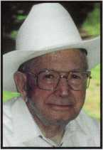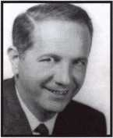

New CRLs:

CALHOUN, WILLIS E ZANNI, JOHN E. BROOKS, LARRY PLASKY, WILLIAM J

COCOA BEACH, FL RIVERVIEW, FL GRANITE CITY, IL CHICAGO, IL

New CMLs:

FULLER, KELLY M. LAS VEGAS, NV RODOCKER, JEREMY FORT WAYNE, IN

Safety in Numbers.

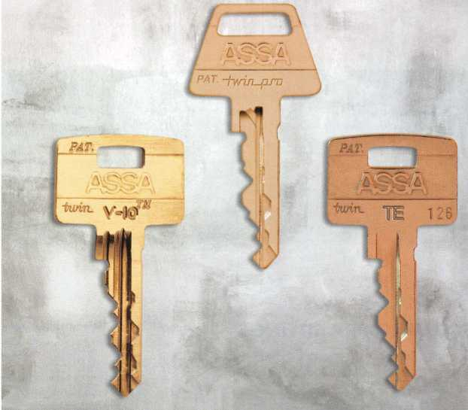

For over 100 years ASSA has been providing the ultimate in key control. And it just keeps getting better. The ASSA Twin V-10, Twin Exclusive

and Twin Pro mortise and rim cylinders make upgrades to high security  
easy. Designed to replace standard cylinders, the Twin series exceeds  
all the standards. For physical security, key control and the ability to  
re-key instantly, there's just one you can trust. ASSA.

ASSA Canada  
3475 14th Avenue  
Markham, Ontario L3R OH4  
Canada

[www.assalock.com](http://www.assalock.com)

an ASSA ABLOY Group company **ASSA ABLOY**

ASSA

High Security Cylinders

ASSA, Inc.

110 Sargent Drive New Haven, CT 06511 (800) 235-7482 Fax (800) 892-3256



Keynotes • October 2003

**DEC I NOV OCT**

**upcoming**

Mi

5

Minnesota Chapter 1

Regular Meeting Dave Nissen

[mnchapternews@aol.com](mailto:mnchapternews@aol.com)

Ohio Valley Chapter of ALOA Membership Meeting 7pm Ryan's Steak House Middletown, OH (off exit 32) Mehdi Zahedi (937) 294-4241



Minnesota Chapter 5

Regular Meeting Dave Nissen

[mnchapternews@aol.com](mailto:mnchapternews@aol.com)

Ohio Valley Chapter of ALOA Membership Meeting 7pm Ryan's Steak House Middletown, OH (off exit 32) Mehdi Zahedi (937) 294-4241



3 Minnesota Chapter Regular Meeting Dave Nissen

[mnchapternews@aol.com](mailto:mnchapternews@aol.com)



3 Ohio Valley Chapter of ALOA Membership Meeting 7pm Middletown, OH (off exit 32) Mehdi Zahedi (937) 294-4241



14-1 8 Pacific Locksmith Conference Holiday Inn - Airport Portland, OR

Stan Hauer 503-325-7334 [www.pla-pro.org](http://www.pla-pro.org)

14

Fox Valley Chapter Membership Meeting 6:00pm Appleton, Wl David Clark

[daveslocknkey@greenbaynet.com](mailto:daveslocknkey@greenbaynet.com)

**UPCOMING PRP SITTINGS**

10/9/2003 8:00AM • Dallas, TX • ALOA

Hope Rodriguez 800/532-2562 X30 10/17/2003 Friday PM • Portland, OR

Pacific Locksmith Association Dan Cunningham F-360-835-1191

10/18/2003 10:00AM • Chamblee, GA

GA Chapter of ALOA John C. Elliott,Jr.,CML,CPS 770/314-7859

10/25/2003 9:00 AM • Sturbridge, MA Yankee Security Convention Jack Hobin 800/209-8266

10/19/2003 9:00 AM • Syracuse. NY Central NY Locksmith Assoc. Ron Smith 315/658-2368

10/26/2003 10AM • Mt. Laurel, NJ • G.P.L.A.

Martin Arnold, CML 856/665-0464

11/13/2003 Detroit, Ml

Locksmiths Security Association Maurice Horne, CML 313-550-5810

11/13/2003 8:00AM • Dallas, TX • ALOA

Hope Rodriguez 800/532-2562 X30

11/16/2003 TBD Montgomery, AL

Alabama Locksmiths Assn.

Amanda Boyd 334/793-5060 11/16/2003 8:00 AM • Ellicott City, MD

Clark Security Products Joan Emrick 619/718-7308 12/11/2003 8:00AM • Dallas, TX • ALOA

Hope Rodriguez800/532-2562 X30

UPCOMING ACE CLASSES

Oct. 6-11

Oct. 14-17

Oct. 22-24

Nov. 13

Appleton, Wl

Fox Valley Technical College  
<http://www.fvtc.edu/>

Jerry Antoon, RL

P-920/735-2406 F-920/735-2414  
Six-Day Basic Locksmithing Course

Portland, OR • Pacific Locksmiths Assoc.  
Dan Cunningham, CRL  
F-360-835-1191  
[danslocksafe@juno.com](mailto:danslocksafe@juno.com)  
(various classes)

Sturbridge, MA • Yankee Security  
Convention • CPS Prep Class (2days)

Detroit, Ml

Locksmiths Security Association  
Maurice Horne, CML  
313-550-5810

November 15 Montgomery, AL • AL Locksmiths Assn. Amanda Floyd 334-793-5060 Closed Circuit TV for Locksmiths

events

CyberLock Access Control for Your Entire Facility

[www.videxxom/lock4](http://www.videxxom/lock4) 7

CyberLocks replace standard mechnical locks and cylinders CyberLocks install without wiring CyberKeys* cannot be duplicated CyberLocks cannot be picked CyberKeys work only when you want them to

03/20/2000 06:14:22 AM

Denied

ilson

East Entrance

Abby Chaney

Pete **Sus$mart**John Michaels

Evelyn Lefler Juanita Banks AndyDunsmote

West Entrance

Records Room

**Computet Room**

West Entrance

Computer Room

Computer Room

03/20/2000 07:28:03 AM

03/20/2000 07:53:15 AM

03/20/2000 08:00:03 AM

03/20/2000 08:12:16 AM

03/20/2000 08:18:52 AM

03/20/2000 08:27:12 AM

**Key Authorized**

Out of Schedule

**Key Authorized**

Key Authorized

**Key Authorized**

Denied



Audit report of every authorized  
and denied entry

541-758-0521 • [sales@videx.com](mailto:sales@videx.com)

GCQ1663

**Locksmith Training**

Sponsored by Fox Valley Technical College • 1825 N. Bluemound Dr. • Appleton, Wl 54912-2277

6-Day Program • Career Change in One Week • October 6-11, 2003

This is a basic locksmithing training course sponsored by FVTC’s Security and Crime Prevention  
Department and conducted by ALOA ACE instructors. Designed for the locksmith shop owner  
who would like to provide entry-level training for new apprentice locksmiths as well as those who

would like to receive professional training that will enable employment with a professional locksmith. The course will allow the student  
to gain enough knowledge to make them a starting apprentice in an existing shop. Job placement locations will be made available at the



time of the class.

To maintain quality the course enrollment will be capped at 12 students. Enroll early!

Curriculum includes:

Key Blank Identification and Duplication Key Codes and Code Equipment Basic Master Keying

Lockset Servicing, Functions, Finishes

Life Safety Codes

Lock Pick Opening Techniques

Pin and Disc Cylinder Servicing Key Impressioning

Lock By-Pass Techniques Exit Hardware

Door Closers

Lockset Installation

Cabinet, Furniture, Mailbox Locks

All tools and equipment will be made available for use during training. Class Hours: 8:30 am to 5:00 pm every day Class Attire: Shop clothes Course Tuition: $995.00

Course Enrollment: See Susan Egnoski in the Criminal Justice Center

or call 920-831-4393

Note: Enrollment deadline is Friday, September 26, 2002

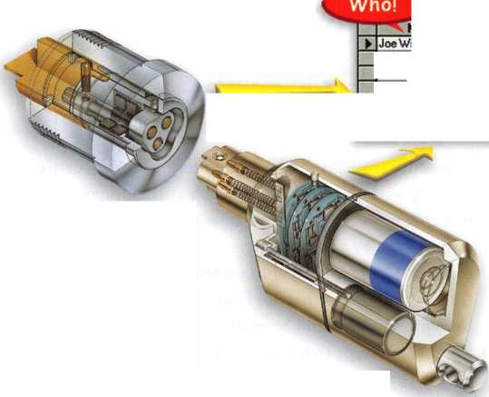

“It is critical that local businesses become involved in homeland security efforts across the country to prepare citizens for emergencies and

teach them ways to be safer.”

John A. Calhoun, NCPC’s President and CEO.

United for a Stronger America

A Safe Workplace is Everybody’s Business by Ann McCrady, CML

Imagine for a moment if you will:

A security specialist and a crime prevention officer are meeting with the local Rotary Club at their regular monthly meeting. The Rotarian’s, including small business owners such as doctors, lawyers, and retail store owners, requested a presentation on security. They are all aware of some of the things that are being done on a national level to improve Homeland Security, but very few really know the specific steps that they should be taking to create an emergency preparedness plan or what else is needed to improve the security of their places of business.

The “security team” begins their presentation by handing out illustrations to the Rotarians and asking these business people to identify the positive security steps and holes in the security of the businesses in the illustrations. One gen­tleman, the owner of a chain of dry cleaning stores has thought about improving the security in his stores for when employees are alone after dark and for employees that open and close. Our dry cleaner is now taking what he already knows about security and is working with a small group of his peers and looking for other things that might be improved. The energy level of the room is high. No group wants to have the shortest list of good and bad things when they reconvene as a large group. A checklist is eventually passed out to each person that provides even

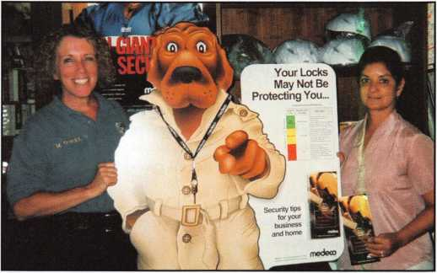

Vacaville Police Department  
Vacaville, California

2

Keynotes • October 2003

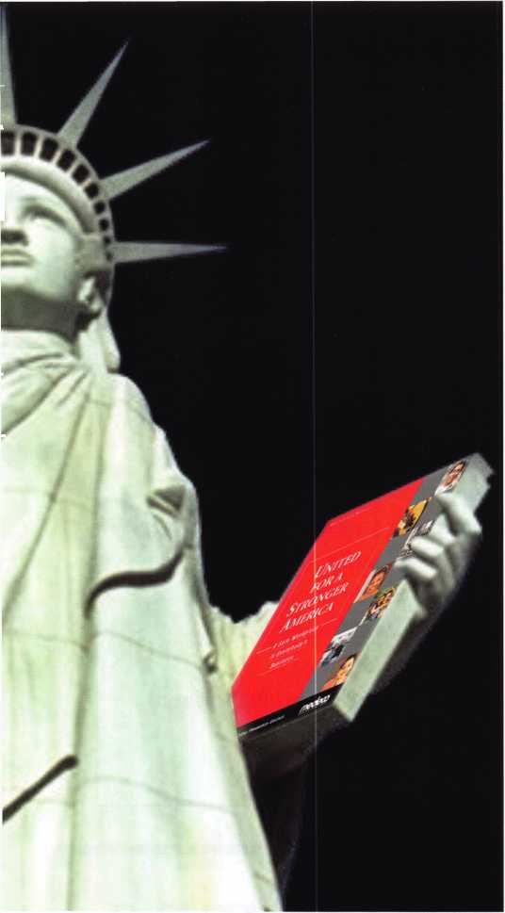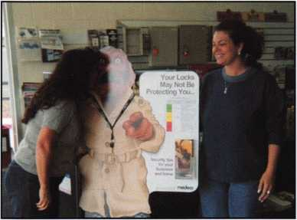

Industrial Lock & Security  
El Segundo, California

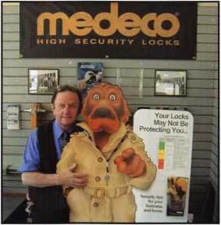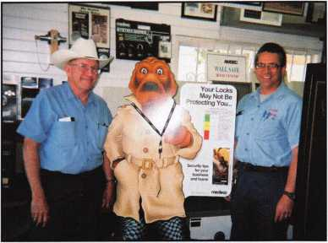

Calvert Safe and Lock Foothill Locksmiths

Derby, Connecticut Hayward, California

more ideas of security items to consider. After a brief dis-  
cussion as a whole group of the issues they were able to  
uncover, each person is given an additional checklist on  
safety and security in their own business - along with the  
invitation to receive a free on-site security survey by

the security team. Our dry cleaner realizes  
that there are some areas that he

had not previously considered  
and thinks that it’s a good  
idea to have a professional  
come over to do a quick walk  
through and make suggestions.

The likelihood that a terrorist  
would target a small business

owner’s deli, law office or dry cleaners  
seems remote. Yet employees do feel  
less secure in the workplace, and it  
seems like a small step for an owner to  
take to at least look at what would be  
involved in improving security. Seeing the  
holes in someone else’s defense systems

makes this owner wonder about the holes in  
his own system.

Medeco and the National Crime Prevention Council have  
partnered to create a toolkit of materials to support the  
example above. This is the United for a Stronger America -  
A Safe Workplace is Everybody’s Business initiative. These  
materials work to:

* Create a partnership between the security specialist  
  and crime prevention officer in a community.
* Provide an engaging, but simple way for business own-  
  ers to learn about possible security risks.

officers to get in front of business owners in their com-  
munity with valuable, practical, suggestions for improv-  
ing security and reducing crime.

The government’s response to the attacks of

September n, 2001, has been extensive - mili-  
tary campaigns in Iraq and Afghanistan, the  
creation of government programs and agen-  
cies (e.g., the Department of Homeland  
Security, Transportation Security

Administration, and USA Freedom  
Corps), the establishment of a home-  
land security advisory system, the  
broad dissemination of safety tips  
(e.g., emergency preparedness, air-

line travel, and mail handling), etc.  
However, there’s still a gap  
between our public response to  
terrorism and its related safety  
concerns pertaining to the

workplace.

In spring 2002, NCPC and Medeco(r) joined forces,

developing an initiative designed to help increase the safety  
and security of businesses nationwide. United for a  
Stronger America: A Safe Workplace Is Everybody’s  
Business was created for professionals whose primary job is  
safety and security, which include crime prevention practi-  
tioners and locksmiths. The outcome is an outline of prac-  
tical measures that ordinary Americans can take to improve  
the security of their workplace. The United for a Stronger  
America campaign has many facets. A Safe Workplace is  
Everybody’s Business addresses a niche that is not covered  
by some of the nationally focused programs, such as airport  
security or mail handling.

• Provide the forum for locksmiths to be seen as physical and electronic security specialists and crime prevention

A common concern stated by the focus groups of draft materials for this project was the practicality of creating a

Keynotes • October 2003

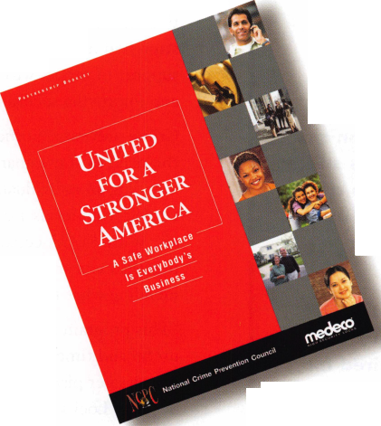

Materials Included in Kit:

PARTNERSHIP BOOKLET

Partnership information, sample press release and letters of invitation for businesses, training materials to copy and use as scenarios, safety and secu­rity surveys to use in the scenarios and references to additional resources.

SECURITY TIPS BOOKLET

Designed to hand out to business peo­ple that attend the training sessions. These booklets are available free of charge. A download of this booklet is available on the Medeco and NCPC web sites.

WINDOW STICKER

To be presented to the business owner after they have completed an on-site safety and security survey. This sticker is intended to be a deterrent to crimi­nals and to work to unite the business community in working together to improve safety and security.

POWERPOINT® PRESENTATION

Available for download from NCPC and Medeco web sites if desired for use in the training.

ADDITIONAL RESOURCES

Other types of business illustrations are also available on these web sites, [www.medeco.com](http://www.medeco.com) and [www.ncpc.org](http://www.ncpc.org).

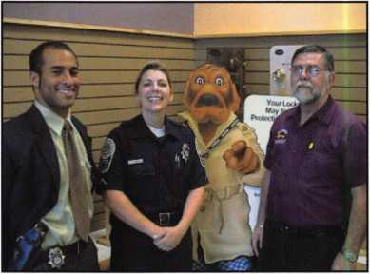

Baldino's Lock & Key Service  
Reston, Virginia

partnership with these two different groups of profession­als. Locksmiths spoke of cases where they felt the crime prevention officer wasn’t interested in working with them because the crime prevention officer felt the locksmith would be doing the police officer’s work. In today’s securi­ty climate, the police are finding their resources being stretched to the limit. More of them are welcoming the support of others with the same goals of reducing crime and improving security in the business community.

Crime prevention officers talked about their concern with the need to stay impartial and not appear to be recom­mending an individual business. They were not aware that certification levels are available for locksmith profession­als. With ALOA certification levels, crime prevention practitioners are given an objective measure in recom­mending what to look for in a security specialist.

“This program provides local businesses with practical, useful and timely information that will help make work­places safer places to be,” said Bob Cook, Medeco High Security Locks President and CEO.

The National Crime Prevention Council’s partnership with Medeco brings together two forces in the effort to stop crime. The NCPC views this effort to educate small business owners as a step in the right direction.

Order materials directly from the  
National Crime Prevention Council at

1-800-627-2911.

Keynotes • October 2003

The United for Everybody’s Bu: states with med

The United for a St Everybody’s Busine states with media £ tion association^^ eral, state chamber

ice of the

governor and att<

Lerce officials, and local

“It is critical that local businesses become involved in homeland security efforts across the country to prepare citizens for emergencies and teach them ways to be safer,” said John A. Calhoun, NCPC’s 'resident and CEO.

eco has provided intensive crime prevention training on physical and electronic security to state crime prevention associations for years for numerous state organizations. This train­ing teaches crime prevention officers about basic lock design, operation, termi­nology, and various types of surreptitious cks. In short, Medeco’s crime prevention ; provides information on hardening the lat is, securing doors and other openings Drop^r security equipment). This train- EotTiegate the need for partnering with a security professional in providing community sup­port, but hopefully increases awareness of all that is not known about specific security solutions.

pecialists. Kentucky,

Virginia and Washington have  
been designated as the pilot

states for this new program.  
The materials are available  
all across the country and

le used in citie§

towns oSlze*

quired is

e desire to

improve the securi-  
ty of your commu-  
nity and the will-

ingness to work  
with a crime  
prevention  
partner to

effectively

accomplish our shared security goals.

America - A Safe Workplace is

is being launched in four

statewide crime preven-

and attorney gen-

security

Locksmiths are referred to crime prevention officers through Medeco Customer Service and through the ALOA web site ([www.aloa.org](http://www.aloa.org)) that is given as a resource in the materials. For more information, please contact your local Medeco account executive or Medeco customer service at 800/839-3157 or

[www.medeco.com](http://www.medeco.com) or [www.ncpc.org](http://www.ncpc.org). The materials may be ordered directly from the National Crime Prevention Council at 1-800-627-2911.

Keynotes • October 2003

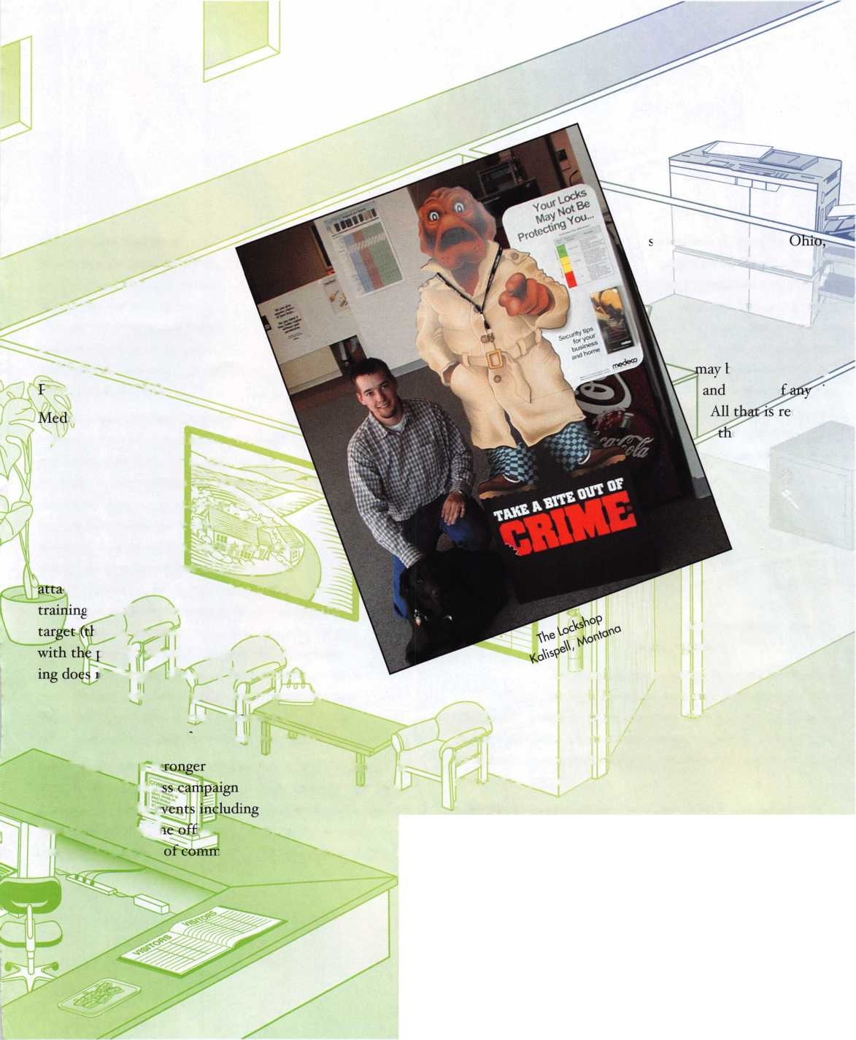

ov^" ;*>. 4B

^Ti:u«>-

na*j#i%ix%.

Keynotes • October 2003



Electronic Access Control Tools

That Pay for Themselves

By Greg Perry, CML, CPS

This month, let’s explore some of the tools available to the access control technician. This is a list of the tools I use, along with a couple I don’t own, but would like to own. Many of the tools you will use are common hand and power tools that you use for locksmithing; others come from the alarm or electrical industry I believe most of you could invest around a thousand dollars in tools, and with the proper knowledge, be able to install and service most elec­tronic access control systems. Electronic access control can be a profitable segment of your business without a high investment in tools.

cally to the control. This is important to prevent a static electric discharge into the sensitive components that make up the control. A discharge of only 30 volts can cause a problem; we begin to feel the discharge at around 3000 volts. This means you can do a lot of damage without knowing it. The damage may be immediate or latent, meaning it may not show up for six months or even more. Shown in photo 2, Arrow makes a stapler that has round instead of square tops. The distance between the legs allows for using different staples for different wire sizes.

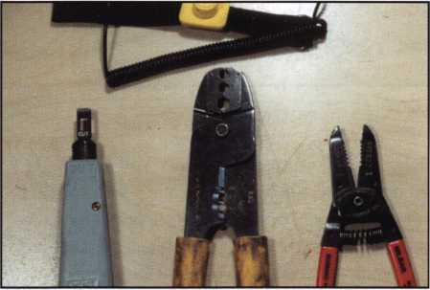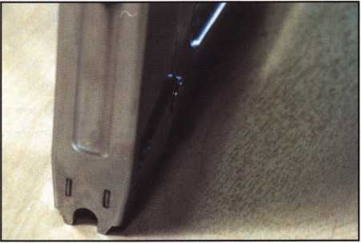

Photo 1

We’ll look first at the extra hand tools needed. A quality wire stripper for small diameter wire is pictured in photo 1, along with a coaxial wire stripper, a punch-down tool, and a wrist strap. The wire strippers help prevent nicking the wire conductor while removing the outer jacket, or insula­tion. If you plan on adding CCTV or are working in some very old system, you need the coaxial wire stripper. The punch down tool comes in handy if you plan on remotely accessing the control via a phone line. The wrist strap shown in the picture is to attach and equalize you electri­

Photo 2

Next up are some the specialized wire fishing tools. Labor Saving Devices, Inc or LSD produces a wide range of tools for wire fishing. You should start with long drill bits to allow you to drill up, down or sideways through a wall to provide a wire path. All of the better long drill bits will have a hole in the tang end to use to pull wire. Some will also have them in the flute end of the bit. These bits are available in lengths up to 72”. Most of the time an 18” or 24” bit along with a 48” or 60” bit will provide all the length needed. I prefer a 3/8” diameter.

Keynotes • October 2003

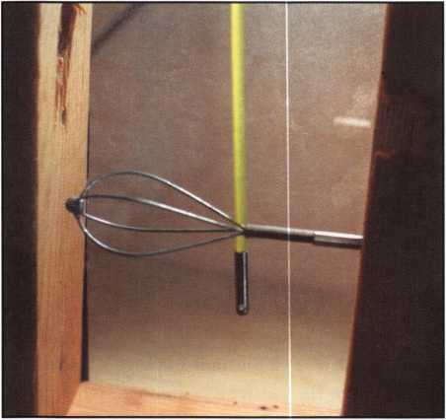

Photo 3

The other long tool used for pulling wire is The Creep-Zit from LSD or metal threaded end fiberglass rods with a wire pulling hole in one end shown in photo 3. These rods can be pushed through 1/4” holes and used to pull wires through walls or up into the overhead. I’ve also used them to pull wires across drop ceilings and through tight spaces in an attic. A basket end is added to help walk it over obstacles. Another use is to add a section of small bead chain to the end of the rod. It can then be pushed past or through insulation and a magnetic retriever used to find the chain as seen in photo 4. Photo 5 takes us to the tool LSD calls the Wet Noodle. It is 10 feet of a small diameter bead chain with connectors for pulling wires. The chain drops down into empty wall cavities and a small hole is drilled — or you can use the cavity behind the electric strike as I did on my demo wall seen in photo 5.

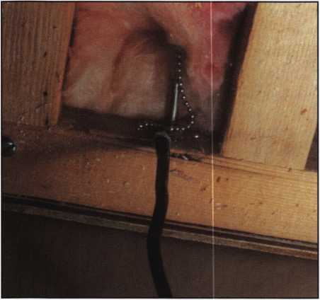

Photo 4

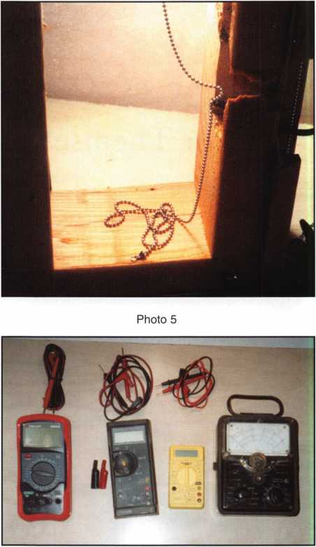

Photo 6

No technician can afford to be without a Volt-Ohm-Meter, VOM, or multi-meter. They are used to measure voltage, resistance, and amperage or current. For a better explana­tion of these terms, see the March 2003 issue of Keynotes. They are available in two basic styles and a wide range of prices. The first option is analog versus digital. An analog multi-meter has a scale and a needle similar to the speedometer of most cars. The left side of photo 6 shows an example of an analog meter. Analog meters have fallen out of use since the age of digital. Digital meters are more accurate at a lower cost. Three digital meters are pictured in photo 6. The small yellow meter is an import available from many of the tool importers. I use these meters in my classes, since they’re cheap (under $10). The problem with them is longevity. I’ve had to replace several over the years and they only are used a couple times a year. Purchase a quality meter that will last in the field, it may cost more in the short term, but the long term savings will be depend­ability and lack of frustration when the meter dies on you when you need it most.

8

Keynotes • October 2003

The two on the left are quality meters. The meter next to the import is a Fluke model 77; this meter has served me well for over 10 years. Far left is a Triplett model 9005 it came out of a co-worker’s truck. Triplett exhibited this year at the ALOA show in Las Vegas. Their meters and other tools are available from ADI Inc, also an exhibitor this year. Quality DVOM’s or Digital-Volt-Ohm-Meters start in price at about $50 and go up from there. The Triplett line of 14 different meters offers good value for your dollar. All three of the DVOM’s shown measure voltage, both AC and DC; resistance; DC amperage or current; and AC current. The different meters will have different ranges, or how low and how high they can measure. Access control work is done in the low ranges, typically under 30 volts and milli- amps of current. One milli-amp is 1/1000 of an amp. To give you a comparison, a 120-watt household light bulb uses about 1 amp.

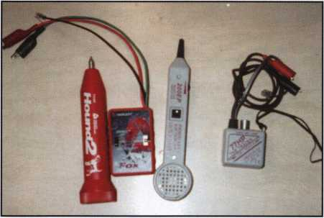

Photo 7

Next up on the list of tools needed are wire tracking or tone generators, and inductive tracers. I’ve used the unit seen on the right in photo 7 from Progressive. The one on the left is from Triplett; they have a newer model out that improves on this basic design. The original design is to add a tone to a wire or pair of wires. The tracer then picks up this tone when it gets near the wire. This can be very handy when wires aren’t labeled, or you’re trying to trace a wire with a break. The problem is it can be difficult to detect which wire is the correct pair out of a larger batch of wires. Triplett’s new design called the Fox 2 and the Hound 2 solved this problem by changing tone whenever the two wires are shorted together. Another tool that can be handy (although a bit pricey) is the cable fault finder. It can measure cable lengths and, if you have a broken wire, tell you the distance to the break. Although I’ve had appli­cations where it might be nice to have, I haven’t purchased one yet.

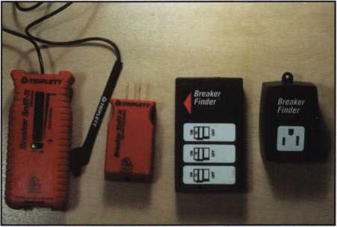

Photo 8

Some other tools that will be added to your collection over time include circuit breaker locators shown in photo 8. They plug into a wall outlet and allow you to find the cor­rect breaker in the breaker panel. Why should you have one? It allows you turn off the breaker as you work on a control. Photo 9 contains a few extra tools like a label printer. Marking the wires and equipment should be a code requirement (it’s not) going back to work on panel years later is made much easier if the wires are marked. Also pic­tured is an outlet tester to tell you if the electrician wired the outlet correctly. The yellow tool on the left side of the picture is a telephone test butt. If you plan on remote access via a telephone line, a test butt is handy to listen in to the signals being transmitted, and also for testing phone lines.

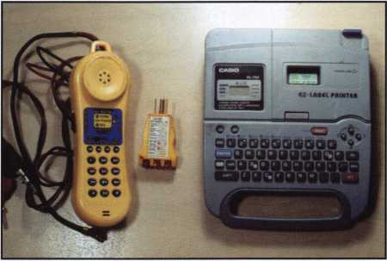

Photo 9

Most access control tools can be added to your toolbox as needed. The wire strippers and cutters, a quality DVOM, and a few wire-pulling tools are the bare minimum. I’ve adapted other tools when I needed to be creative and added others as a job would pay for them. Remember: You’ll find that you’ll need some of the tools while on the job, and it’s not always easy to stop in the middle of a job and come back later after purchasing the tool. So buy them ahead of time. Anticipate your tool needs and you’ll find electronic access control can be quite profitable.

Kpvnntes • Ortnhpr 9003

Cycle Chronicles Part i

A Triumph in Every Way By Ray D’Adamo, CML

Keynotes • October 2003

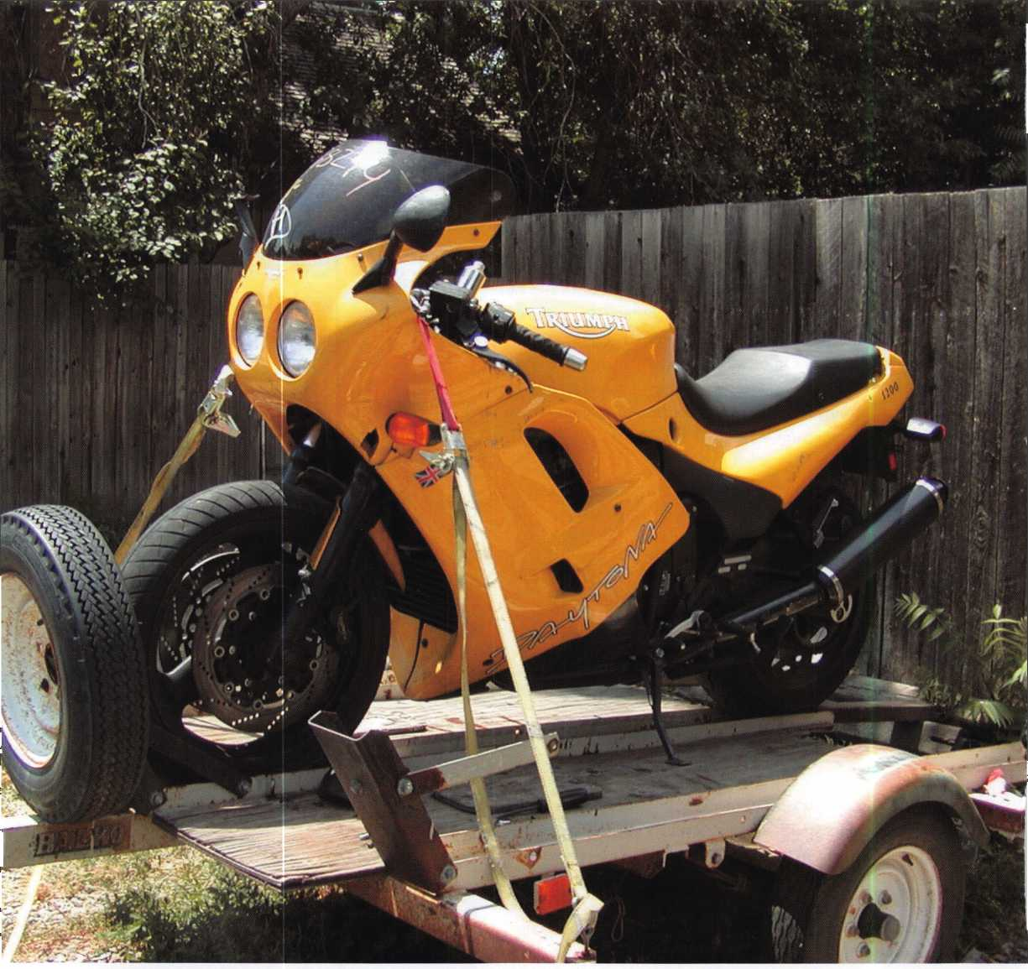

The owner of this 1995 Triumph Daytona 1200 (Photo #1) bought it at an auction. He then purchased 2 Triumph original key blanks off the Internet and took everything to a locksmith. After 3 days and having trouble completing the work, the locksmith suggested taking the bike to us.

I had serviced older Triumphs from as far back as the 1960s, but never one from the 1990s. Information on the later models is sketchy at best. I was anxious to see what was waiting in store for me. I began analyzing the situation.

The previous locksmith had taken a standard after market key blank for Yamaha and modified it to create a work key. That was smart! Then without completing the work on the bike, duplicated it onto one of the two Triumph original key blanks. No comment! Using both keys as reference, I estimated the cut sequence of these keys to be 4433232. I counted the discs in the ignition by using a pick. Starting at the back of the plug as I slowly raked the discs, I heard 7 snap under spring tension. Both keys turned from “Off” to “On” in the ignition lock but could not be turned to “Lock” and “Park”. That wasn’t right! I repeated the disc counting process in the tank and counted 4 discs. Both keys turned quite far in the tank lock but not far enough to unlatch it. That bothered me! I looked into the tank lock keyhole and saw that the first disc had been damaged and was not mov­ing. That’s why I only heard 4. There were really 5! I also noticed that the tip of the key is what was used to stop it in the lock, implicating the tip cuts operated the lock.

I raked the seat lock and counted 3 discs, but neither key turned in the lock. Traditionally the core set of locks fitted to a late model bike of this caliper is keyed alike.

The initial prognosis was the ignition lock was not working properly, the tank lock was damaged, the seat lock did not have a key and things were not looking good for this British bad boy.

After exhaling all the bad news, I paused for a minute and sat down on the trailer next to the bike, wishing I were the locksmith its owner had called first. I mean, it had seen some rough rides, it had been in an accident or two and the problems with the lock system seemed to only make matters worse, but with a little TLC this battered machine could be great once again! A fully operational, stock lock system complete with an original key would make it that much more exciting! With new resolve I continued my analysis.

It wasn’t long before things began to fall into place. The locks began to look painfully familiar, very Kawasaki-ish, especially the “KM-3”, which was cast into the ignition face. I had seen “KM-8” cast into other Kawasaki ignitions of the period, but never a “KM-3”. Could this system be similar, possibly produced by the same Japanese lock manu­facturer? I looked at the tank and seat locks again. They were Kawasaki dead ringers. I glanced at the original key again. The blade length was different, but it looked similar to newer Kawasaki keys. ‘Ah So!” I exclaimed! “Time to get to work.”

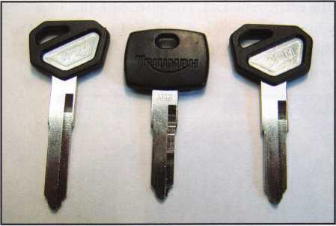

Assisted by a curious apprentice we began searching the Kawasaki section of our keyboard, seeking a decent substi­tute work key for this Triumph original. While repairing the lock system and fitting the 1st key we were going to ruin a key blank or two. One of them was not going to be the only Triumph original we had. The Ilco X259 was close, but among its other problems the blade was too short. The Triumph blade needed to be .920 from the shoulder to the tip. At 1.035 inches the blade on the Ilco Kawasaki key blank for Ducatti, KW14 was too long but fitted the bill in every other way. At 1.120 inches, the Ilco KW15BP was much too long, but it was also perfect in every other way and since we had gobs of KW15BPS, we duplicated the Triumph original onto it and made a work key. Photo #2 shows the Ilco KW15BP on the left, the Triumph original in the center and the modified KW15BP work key on the right.

Generally fitting a 1st key to Japanese bike systems, which utilize partial disc placement where the ignition contains all system discs while the other system locks contain only partial disc content, can be accomplished by combining the

Keynotes • October 2003

disc information of the non-ignition cylinders. We decided to go on that premise and began with the tank lock.

Attempting to open the tank lock using only the previous locksmith’s work key resulted in just bending the key With a crushed and jammed disc, opening the tank lock would require a different approach. We took the work key, cut off the blade, put the blade into the lock far enough to follow it up with an appropriate tool to increase turning pressure and began turning the plug. Suddenly we heard a “click” and the tank popped open! I was pleased. My apprentice was stunned! We taped closed the tank opening and then removed the entire tank lock, complete with the hinge. Photo #3 displays the tank lock and the key blade used to open it. We then disassembled it to repair it and begin manufacturing a ist key.

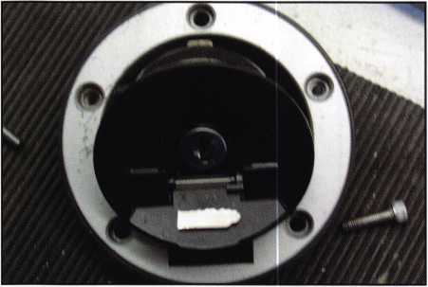

Photo 3

To disassemble the tank lock, begin by removing the 2 screws securing the latch to the bottom of the lock and remove the latch and latch return spring. Next remove the next 2 plates along with the 4 springs beneath them. These parts make the lock “pop open” when it is unlatched. Then remove the metal ring covering the rubber “O” ring at the rear of the plug, lift out the “O” ring with a suitable tool, remove the metal spacer beneath the “O” ring, depress the plug’s spring retainer and push the plug out the top of the assembly. Photo #4 displays a disassembled tank lock.

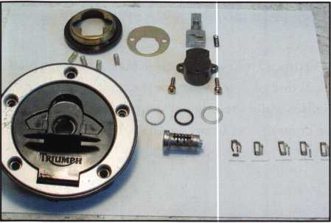

22

During the disassembly we removed the discs and meas­ured the amount of disc material opposite the spring post of each disc, including the damaged disc, as seen in photo #5. This revealed their relative increments. There were 5 evenly spaced discs, which utilized 3 evenly dropped steps or depths. Japanese bike systems usually utilize 4 depths, but we had no way of knowing if we were looking at 1 through 3 of 3 steps, 1 through 3 of 4 steps, 2 through 4 of 4 steps or what. After inserting a blank into the plug, measur­ing the amount of disc material extending from the plug and noting the spacing between the discs, we found 2 code cards, which with 1 slight modification could be used simul­taneously to generate the tank key. We added a 7th spacing position onto the CMC50 at .689 inches. This allowed us to place the tip cut on the key, which coincided with the last disc in the tank. When we wanted to place a cut on the key we used the CMC50 for spacing and the CMC80 for depths. With the tank lock reassembled, the last 5 cuts on the key were 13232.

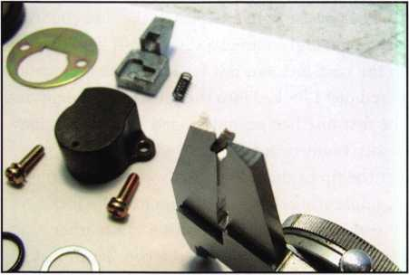

Photo 5

Next we decided to pick open the seat lock (photo #6), and remove and disassemble it to obtain more bitting information. With only 3 discs contained, the seat lock opened right up. Before disassembling the seat lock, it must first be removed from the frame. To remove the seat lock, remove 2 Philips head screws from behind the lock, which secure the assembly to the frame, along with the lock shield, which is a plate that protects the back of the lock from road debris. We used an offset screwdriver. Next, move the assembly to the right and out from behind the frame. With the assembly still connected to the cable, which triggers the seat latch, rotate the assembly 180 degrees (photo #7) to reveal the back of it. Remove the 2 small screws securing the back plate to the assembly and remove the back plate. Next, lift out the return spring (photo #8). Lift out the plastic pawl and displace it enough to access and depress the plug’s spring retainer (photo #9), and push the plug out the front of the casing. Photo #10 displays the removed plug, nestled in the back of the lock

Keynotes • October 2003

casing. The seat lock’s disc values were found to be 413, and the 13 in the seat lock were the same 13 in the tank lock. Now we had 4 depths found on the CMC80 code card, and if this bike sported a 7 bit keyed alike system, we now knew what 6 of the 7 discs in the ignition were, 413232, however this key did not work the ignition lock at all. We then decided to go for broke and progress the 1st position on the CMC50 code card. Step #3 did it! The final bitting sequence was 3413232, and this key turned to all ignition positions and worked the other 2 locks in the system flaw­lessly! Now that we had a fully functional 1st key we trans­ferred the correct bitting sequence to the Triumph original, for an original 1st key, and photo # 11 displays the work key and the Triumph original key.

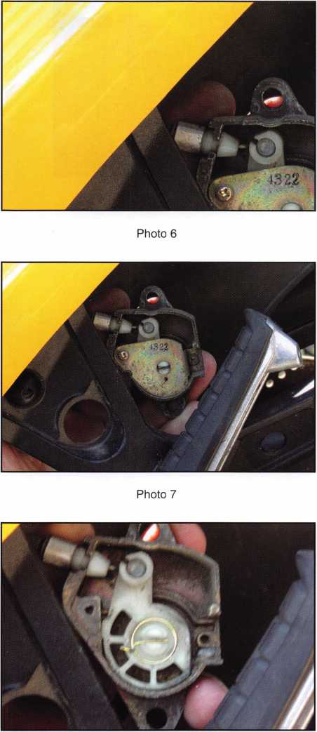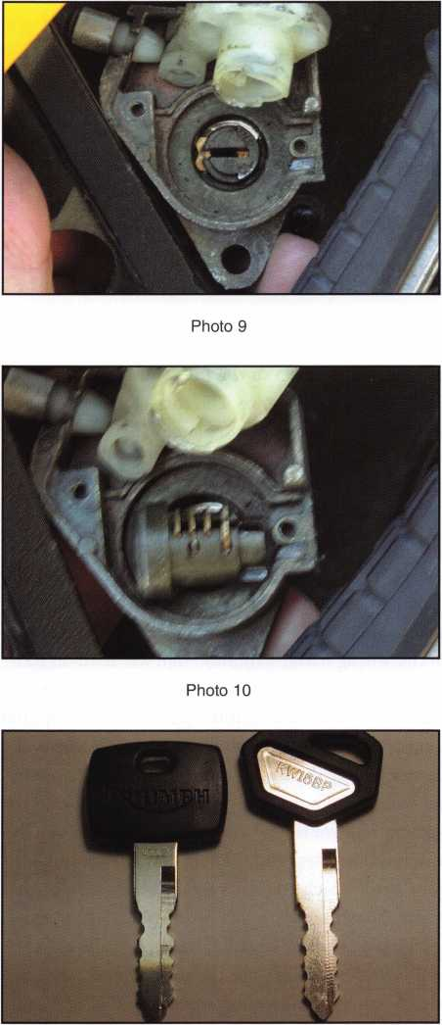

Photo 11

When we were finished fitting the 1st key we felt good, but I was not finished. I still had questions, like how difficult is removal and disassembly of the ignition lock and how long does it take to remove and replace? How does the ignition lock come apart? How is the ignition plug removed? Can the plug be removed without removal and / or disassembly of the ignition lock? The bike owner was going to be out of town for a few more days. I called him with the good news and asked if I could do some research on the bike while he was still away, promising to have it ready for him when he returned. He was so happy that things went so well, he did­n’t care what else I wanted to do with the bike, so we went back to work.

Photo 8

Keynotes • October 2003

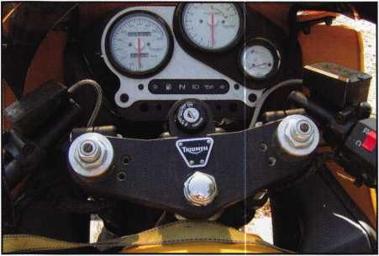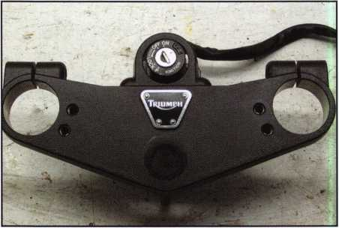

Photo 12

Photo 13

The ignition lock is secured to the fork stabilizer from beneath with 2 shear head bolts. The fork stabilizer (photo 12) is the black, 1” thick aluminum plate, which stabilizes the steering system by linking the top of the 2 fork tubes with the steering head of the frame. We decided to remove the fork stabilizer with the lock still installed. Removing the fork stabilizer requires a #6 metric Alan wrench, and takes about 30-45 minutes, because the handle bars and all the bike’s control systems come together in this area. After removing the fork stabilizer and disconnecting the ignition lock from the wiring harness (photo #13), we used an EZ- Out (photo #14) to remove the lock from the stabilizer. After the lock was removed we unsnapped the face cap, but still saw no apparent way to remove the plug. We decided to start disassembling the lock from the bottom, by remov­ing 2 small shear head bolts, which secure the bottom plate to the lock and remove the bottom plate. Next, lift out the plastic switch (photo #15) and then lift out the terminal plate (photo #16), which connects to the bike’s wiring har­ness. Lift out the white plastic insulator (photo # 17) just above the two piece bolt assembly. To remove the bolt assembly (photo #18), either use the operating key or manipulate the plug to midway between the “On” and “Off” positions and remove the bolt assembly. Next, remove 2 small screws securing the metal plate found beneath the bolt assembly (photo #19) and lift out the plate along with the center actuator shaft. Next remove the plug return spring and the plug limiting cam (photo #20), which prevents over-rotation of the plug. Locate the plug’s spring retainer disc (photo 21), depress it and push the plug out the face end of the housing. Photo #22 displays the dis­assembled ignition lock.

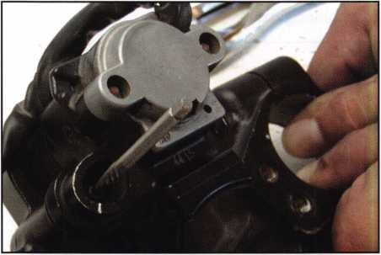

Photo 14

Keynotes • October 2003

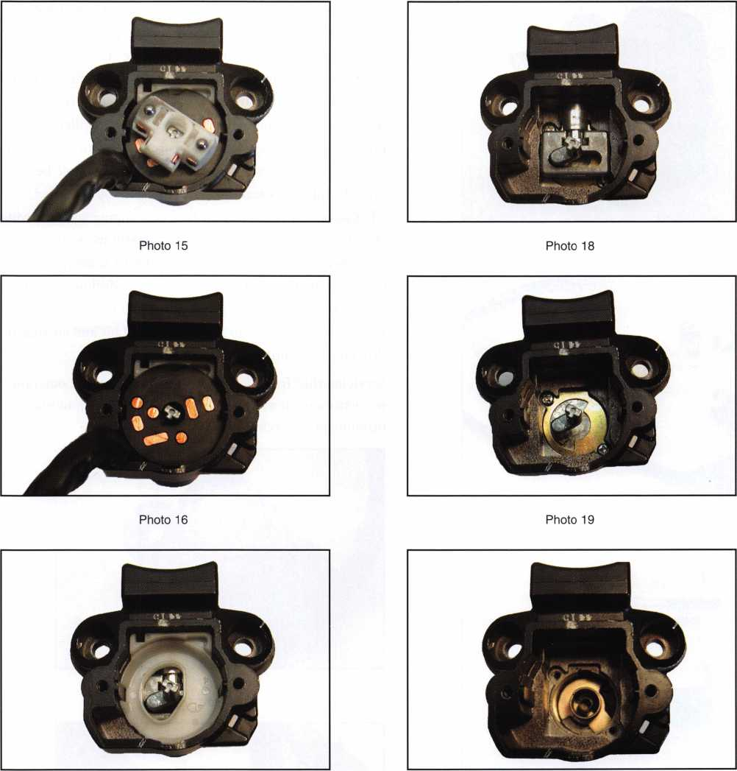

Photo 17

Photo 20

A fully operational, stock lock system complete with an original key would make this Triumph

even more exciting!

Keynotes • October 2003

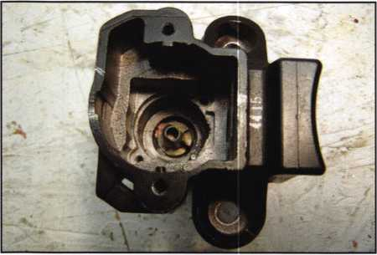

The top of the keyhole is the end of the keyhole (photo #24), which points to the various switch positions noted on the face of the lock. When drilled in the “Lock” or “Park” position, the resulting hole in the casing puts the assembly at greatest risk to be bypassed, so a different position is preferable, however any retainer access hole drilled in any position can be plugged to re-secure the retainer. The next question we asked was can this retainer access hole be drilled while the assembly is still installed on the bike?

That answer is yes! I suggest first unsnapping and removing the plastic case cap, but photo #25 clearly shows the drill point below the stabilizer bar. Removal of some faring parts may be required to provide enough drilling room for this method, or perhaps this method can be accomplished without any parts removal if a short drill bit and an angled drill chuck are utilized.

Servicing this Triumph was very exciting and the outcome was extremely rewarding. See you next time for another installment of Cycle Chronicles.

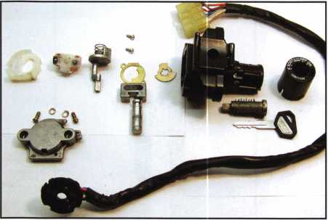

Photo 22

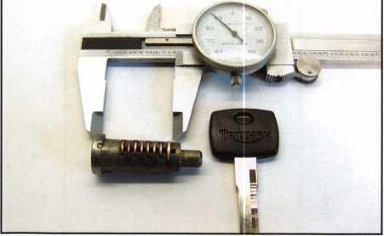

Photo 23

What if the plug cannot be turned? We discovered the answer to this question after the lock was disassembled. The plug can be removed without disassembling the lock by drilling a small retainer access hole through the lock housing directly over the plug’s spring retainer. This retain­er is located 1.190 inches from the face of the lock (photo #23), and its center is in line with the top of the keyhole.

Photo 25

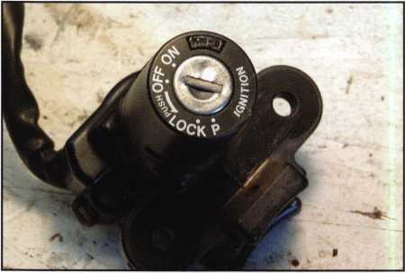

Photo 24

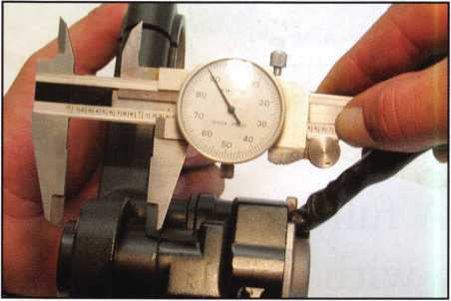

Keynotes • October 2003

*Reno, Nevada: In 1859, Charles Fuller built a log bridge across the Truckee River and charged a fee to those who passed over it on their way to Virginia City and the gold recently discovered there. Fuller also provided gold-seekers with a place to rest, purchase a meal, and exchange information with other*

***prospectors.***

*SZ*

Keeping up with the latest the industry has to offer has never been more impor­tant for safe technicians. **Time is of the essence** when it comes to education. New developments spring up each year, making top-notch safe classes as good as gold in our ever-changing environment. The only chance to get **world-class education** and meet with the **industry's top safe technicians and suppliers** is the SAFETECH Convention and Trade Show. SAFETECH 2004 offers you a chance to **explore your profession** in ways you never thought possible. Register now to benefit from the future of this exciting industry.



**SAFETECH 2004**

MARCH 20-28  
JOHN ASCUAGA'S  
NUGGET RESORT  
RENO, NEVADA

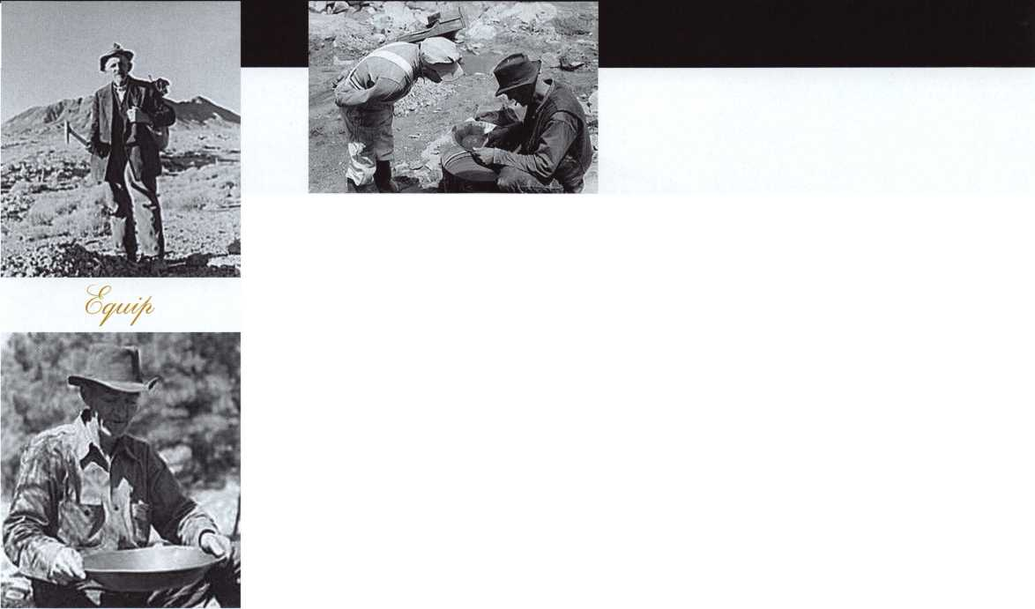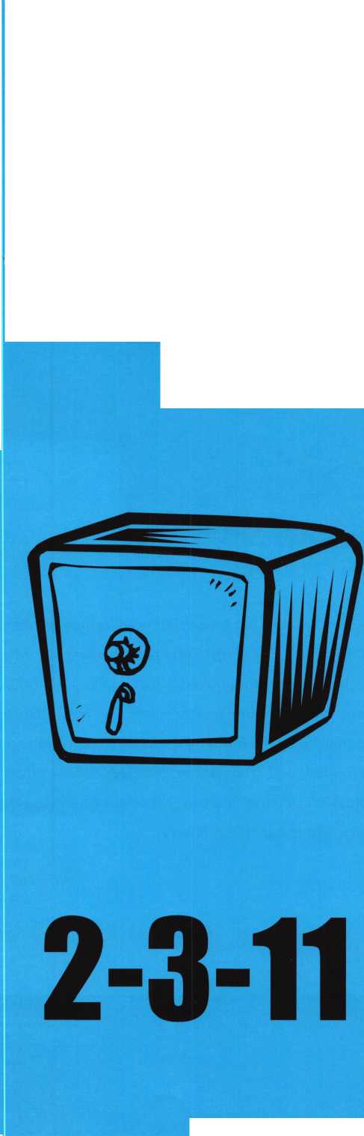

Taking the Pony Express to No Man’s Land

Crazy combos (2-3-11?) spell “headache”

By Greg Perry, CML, CPS

It sounds like a date some time in the future; it can’t  
possibly be a safe combo. Or can it? The call came in  
via our call tech, “How much to open a gun safe on a  
Sunday that’s 70 miles away?” I called the customer;  
he’s 81 years old, swears the combo he’s been using is  
2-3-11 and he wants in his safe now! I quoted a  
minimum of $600 plus repairs to open

the safe. “Fine, but you have to open  
the safe because that’s where the  
money is” was his reply. “Another  
locksmith has been here for an  
hour and said to call you.” I  
loaded my laptop into the truck  
and headed in his direction.

Once there, I half-heartedly tried  
the numbers given, and it didn’t open.

The gentleman had just been released

from the hospital and seemed a little senile.

He swore the safe was purchased new with that com­bination. I ran the dial to see if any numbers would give themselves away Nothing there, so I checked my laptop for similar units. It was a Sunday and I needed to be back home. My personal photo library did not contain this model, so I checked McOmie on Gun Safes from the Dave McOmie’s Safe Book Collection CD. I found a similar unit; the handle is to the left of

the lock, the hinges looked the same, with almost the  
same paint style. The only difference in the paint is  
this safe had a pair of horses standing on their rear  
legs and Dave’s picture says “Pony Express” on the  
label. I’ve seen several safes manufactured by Sun

Welding or C&H Welding; most technicians  
(including Dave) file them under Pony  
Express, since that is the name on the

door. Dave’s photos show the lock to  
be mounted RH, which makes  
sense since the handle is to the  
left. Most of the time the lock  
points to the handle.

Right hand it is, or should be, and  
since the dial didn’t disclose any  
numbers quickly, I pulled the dial and

drilled a scope hole about 1 1/4 inches at  
92. I expected to enter the lock case in the  
area between the fence and the bolt. This is a great  
area to enter the lock case. The hole stays under the  
dial ring, and if the bit grabs — entering the lock case  
— it doesn’t tear up the wheel pack, which would  
complicate an easy opening. Another advantage to  
drilling away from drop in concerns the repair. Since  
I’ve only drilled a scope hole, if a burglar should try to  
follow my hole location they would need to have, and

Keynotes • October 2003

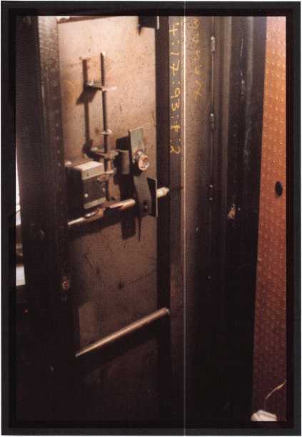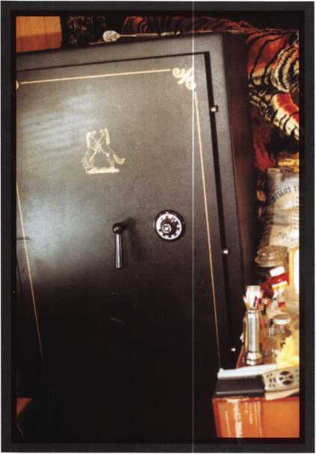

understand how to use, a scope. This allows for a repair without welding inside or door removal to weld outside. Gun safe doors are not always easy to remove, and I prefer not to weld inside a home. When I’ve drilled a scope hole and don’t want to weld, I’ll plug the hole with a ball-bearing held in place with steel stick or JB Weld. I’ve also used hard­ened set-screws inserted from the inside and peened the edges of the hole to help prevent removal.

As I entered the case (or at least where I thought I should be entering the case), I found a screw. The lock was not mounted right hand after all — it was vertical down. This complicated the opening a little.

I also found the combination was close to what the gentleman had stated. That actually caused me more grief than the hole location. I could dial the combi­nation to the area around the hole, and I could see the fence about 25 numbers away. But, getting the wheel pack to line up at drop in took many tries. After getting the safe open, I serviced the lock and replaced the dial. Testing the numbers showed the numbers to now be 11, 12, 20. This is exactly 9 num­bers different on all three wheels. Why did they change but maintain the same distance? Any guess­es? The original dial was splined at 41; the new dial is splined at 50 or 9 numbers different. This means the combination was correct.

Although I didn’t find any obvious problems, my thought is perhaps a fly was sticking, and I didn’t check for that before drilling. I jumped the gun and reached for the drill a little too quick. I didn’t believe any one who sells safes would set such a combina­tion. It breaks a couple of major rules for setting combinations: one, setting numbers a minimum of 10 apart, and two, setting the last number in the forbid­den zone. Next time, I’ll spend a little more time on diagnosis.



Keynotes • October 2003

OSI Security Devices is a privately held corporation that was founded in 1986 in Sunnyvale, California. All members of the company’s Board of Directors hail from the high-tech defense electronic, software engineering, the security industry, or the legal career fields of Silicon Valley. Shortly after its founding, OSI Security Devices introduced one of the Worldis First battery-operated standalone electro-mechanical locks: the OMNILOCK/E OM250. The OM250 firmly established OSI’s reputation of strength and reliability (it should be noted that OSI still manufactures the OM250 some seventeen years later!). Improvements to the keypad-programmable product line came in 1994 with the OMIOO, 300, and 500 series systems. In 1997, OSI relocated to San Diego, and in 1999 the company embarked on an ambitious program to upgrade the product array. Incorporating feature-rich software and advanced magnetic card and proximity technologies, the OMNILOCK 2000-series systems offer the ability to enroll up to 2000 users per lock and the ability to manage facilities of over 65,000 users. In line with its technical backbone, OSI currently offers customers internet-based technical or training support over the internet via desktop streaming. This state-of-the-art service allows our technical support personnel to come right to the desktop of customers nationwide and perform demonstrations or assist customers with their computer-based OSI software. Please give us a call and then visit [www.omnilock.com/help](http://www.omnilock.com/help) for a live demonstration.

OSI presently offers Keypad-only systems (OMIOO, 300, and 500) as well as Magnetic or Proximity card technology systems (OM2000 or OP2000, respectively). All of these technologies are available in the following hardware configurations: Cylindrical (Schlage or Arrow), Mortise (Schlage or Falcon), Wall Mount (for controlling electrified hardware such as electric strikes, magnetic locks, elevators, or electric gates), and Exit Device Trim (Von Duprin, Corbin-Russwin, Yale, Precision, Sargent, and Arrow). Additionally, OSI offers Quick Adapter products that adapt to existing Schlage Cylindrical or selected Mortise locksets. The Cylindrical Quick Adapter works with the Schlage D-50, D-53, D-60, D-66, D-70, D-73, D-80, D-82, and D-85 locks with either standard or interchangeable cylinder cores. The Mortise Quick Adapter is currently available for use with the Winfield auto-deadbolt lock; but will soon be available for use with the Schlage L-series, the Corbin-Russwin Emhart series, and the Best Mortise locks.

Another group of exciting new products is the OMNILOCK OP100, 300, and 500 series. These locks received UL approval in June 2003 and will be available late this summer. These locks allow end users to program keypad codes or HID proximity cards at the door using the WP4000 printer or any approved PocketPC/E. Additionally, proximity credentials may be enrolled in these locks without the use of a printer or PocketPC and key­pad-code users may be batch enrolled using text files that have been created by the end user on their personal computer. Also, the audit trail from the OP135 may be uploaded to a personal computer from the PocketPC and displayed or printed as a text file. The OP135-series locks offer the same time schedules, user groups, and audit trail features of the keypad-only OMIOO, 300, 500 series systems. Please visit [www.RentalLock.com](http://www.RentalLock.com) for a look at the brand new and revolutionary OEM product that we have designed and manufactured for the timeshare and property management market.

As new products like the Mortise Quick Adapter, the OP100, 300, and 500 Series Proximity locks, and the RentalLock emerge, OSI will continue to establish itself as the most technically innovative and responsive company in the industry. OSI Security Devices is dedicated to ensuring cus­tomer satisfaction while maintaining its reputation for American-made quality, integrity, and reliability.

OMNILOCK Standalone Access Systems: since 1986 the most  
reliable and easiest to install solution for all applications...

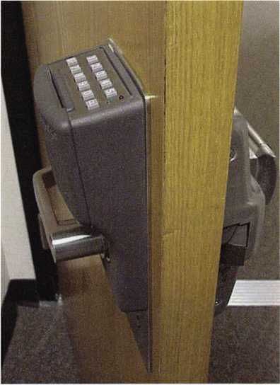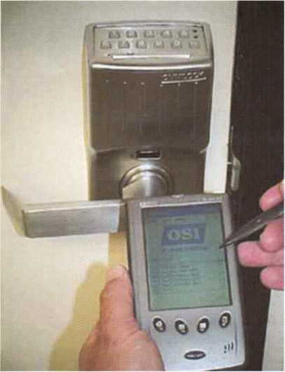

More...Faster...Easier...Better!

* **PC-Based yet Standalone**
* **HID Prox or Mag Cards**
* **PocketPC Programmable**
* **2,000 Users per Door**
* **50,000 Audits per Door**
* **No Holes to Drill!**
* **No Wires to Run!**
* **No DTMs, laptops or plug-in  
  cables at the Door!**
* **Program in seconds, not  
  minutes like the others**
* **UL-Rated and Approved**
* **Built-in on-door Diagnostics**
* **Rugged Grade-1 Locksets**
* **Made in USA with PRIDE**

**OSI Security Devices** 1580 Jayken Way Chula Vista, CA 91911 phone: 619.628.1000 fax: 619.628.1001 **[www.omnilock.com](http://www.omnilock.com) [sales@omnilock.com](mailto:sales@omnilock.com)**

Available in Cylindrical, Mortise, Panic/Fire Exit  
Hardware, Wall Mount System con guration



[controls electri ed hardware), or Quick Adapter  
{adapts to **Existing** Schlage D Cylindrical locks).

Start Your Engines!

The Early Stages of ALOA’s New Shop Certification Program

By Hans Mejlshede CML



As the largest locksmith association in the world, ALOA has a standing obligation to try to  
better the image of the locksmith. What is influencing our public image? Two of the major  
factors are our physical appearance and our knowledge level. How do our shops look? How  
do we dress? Do we have the right answers? Do we know most of the new technology? Do  
we give our customers quality work for a fair price?

ALOA has worked on our image in the past: Think about the huge amount of education  
that the PRP program has created. ALOA is doing it today - look at the magazine you  
receive every month, and look at the annual convention with its many educational classes  
and its valuable information about the products available on the market today. ALOA  
also has carried out costly, large media ad campaigns to promote the image of the lock-  
smith over the years. ALOA has been successful at improving the knowledge level, but  
not very good at improving our physical appearance. We could do better in both areas!



Keynotes • October 2003



How can ALOA improve our physical appearance and our knowledge level? By creating a reward program. The inten­tion of the ALOA Board is to start a new membership sec­tor: the ALOA Certified Security Center. We have formed a Certification Committee, of which I am your humble chairman.

We are convinced that most of the manufacturers are going to support the program because it is to their benefit to do so. I am also convinced that, after some years, when we have gained strength, we can launch a strong marketing program together with the manufacturers that include some very special deals.

There is no need to exclude the mobile-only locksmith, we  
could launch a similar program for them called, “the ALOA  
certified security installer.” However this article’s main  
focus is on the shops.

In order to get things moving and to get results, we have to  
demand many things from the ALOA members who would  
like to participate. Exactly how much we do not know at  
this moment. Here are some ideas:

* Neat and clean shop
* Neat and clean service vehicle
* Rated safe for storing customer information
* Rated alarm system
* Quality locks and hardware on our own doors
* Quality control system operating in

the company

* Certain classes passed at the ALOA  
  ACE program
* Background checks for employees
* Dress code for all employees
* A bonding program for all  
  employees
* A training program for all  
  employees

Most of the work has to be done  
by the members, but ALOA also  
has a lot of work to do. Some of  
these challenges could be to:

* Develop the necessary ACE classes
* Find the necessary instructors and  
  teach them
* Design a new quality control system
* Design theme posters several times a year for display
* Help with the background checks for new employees
* Implement a strong marketing program
* Implement an inspection system
* Implement a new bonding program

A very simple quality control system for the centers could  
be an annual “Customer Satisfaction Survey” and a “Call  
Back” system, where the cost of call-back is tabulated. It  
would really be nice if ALOA, in the future, could publish  
these figures and show that, by focusing on these figures,  
they did improve. Incidentally, these two controls are ele-  
ments in the ISO 9001 quality control system.

Education? Big question! How much? As I see it, a five-day  
program for the shop owners or managers is a must, as a  
starting package. Content? Marketing and quality control?  
Then a strong incentive to take special ACE classes, where  
the reward could be an extra level of certification for spe-  
cial knowledge. Maybe some mandatory classes for all  
employees?

What kind of results do we get from an improved image? A  
better market share! I am convinced! Believe me, there are  
other areas in the world, where the locksmith has a much  
higher market share. There is room for improvement in the  
United States. We can charge a better price for our servic-  
es! Why can a computer tech charge more than we do?  
Because he has a better image!

ALOA is not a very wealthy organization;  
a program like this has to finance  
itself. After some minor start-up  
cost, the program must generate a  
positive cash flow. A huge pro-

gram like this cannot start  
overnight. I believe that it  
could take up to two years  
before the first group of  
ALOA certified security cen-  
ters could be advertised and  
promoted. There will be a great  
deal of work before that, and a  
thousand questions to answer.  
Please help us with some of them!  
E-mail me your comments to this pro-

gram at: [hm@mejlshede.dk](mailto:hm@mejlshede.dk).

The thoughts in this article were presented at the annual membership meeting in Las Vegas. We also had a rough draft of a questionnaire available. The winning requirements were:

* A dress code for all employees
* A background check for all employees

Almost everybody thought that these were the most important issues. On top of that, there was a lot of support for the idea of an ALOA certified security center. Thank you for your consideration of this exciting new idea!

Keynotes • October 2003

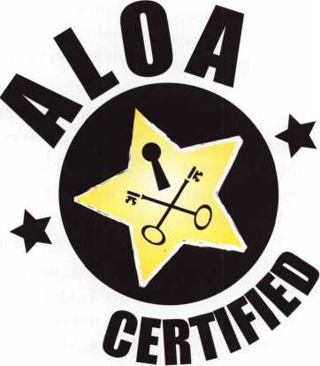

D&D Technologies Adds High-Security Door and Gate Locks to Gate Hardware Lines

By Maureen Williams

To meet the growing demand for high-security gate and door hardware, especially for commercial applications, D&D Technologies has introduced a new line of architec­tural stainless steel locks for gates and doors, the Forte™ line. D&D Technologies has been well established in the fencing industry for over a decade, with its gate hardware being used OEM or distributed by virtually every major fencing company in the U.S.

“Listening to locksmiths who visited our exhibit at the ALOA Show,” D&D CEO David Calabria said, “we learned that many locksmiths also service and install locks on gates. We’re now introducing all of our lines to this industry, and several of the major locksmith distributors are or will soon be distributing our products.”

“When national security concerns intensified in the U.S. and around the world,” Calabria said, “our design engineers set out to develop a high-security range of locks to enhance our well-established array of injection-molded polymer gate hardware.

“The Forte HaspLock and the Forte PullBolt,” Calabria continued, “are the results of that effort. Made from 316- grade stainless steel, these extremely high-quality commer­cial and industrial gate locking security products are ideal for use in marine or other corrosion-prone environments. They’re highly resistant to hacksawing, levering and oxy- acetylene cutting, and are extremely versatile. They can be used on gates as well as storefront or shop doors.”

D&D has designed the Forte HaspLock to replace a con­ventional hasp, staple and padlock arrangement, and to provide greater security than traditional locking devices.

In many situations, Forte can be used as add-on security to bolster existing gate or door locks. The double-hinged HaspLock model is ideal for use on vending machines, shop or truck toolboxes and other “cornered” applications. The Forte HaspLock can be custom-shipped with multiple hinges (coupling extensions) for custom applications. The HaspLock can provide security for storefronts, doors, gates, factories, storage units, garages, containers, boats, stables, cabinets, and other places where valuables are stored (and where egress is not necessary).

The dedicated gate HaspLock is ideal for most round-post or square-post gate configurations and also for driveway

gates. It can fit to either hinged or sliding gates, and can be installed to gate gaps of up to 4.”

The Forte PullBolt Face-Mount model can be face-mount­ed across gate and door frames. The lock bolt slides snugly across into the heavy-duty mount for optimum security.

The Forte PullBolt Side-Mount model can also be mounted to the face of gate or door frames, either adjacent to the locking frame or parallel to the ground surface. A keeper plate is used for added strength and optimum aesthetics.

The PullBolt is ideal for applications such as the backs of trucks or trailers, added security for sliding glass doors, and many other uses.

Calabria added, “These stylish, quality stainless steel locks are designed to be used as primary locks, or can be used as add-on security devices. They feature a standard 6-pin lock cylinder, and can be keyed alike or master-keyed, or the cylinder can be replaced with high security cylinders.”

The locking mechanism is a deadlocked design, as opposed to a snap lock, which protects the lock from tampering or prying. Like other D&D products, Forte locks won’t rust or corrode, and come with a limited lifetime warranty.

‘At the ALOA show,” Calabria said, “we saw keen interest in our Lokk-Latch®, Lokk-Latch PRO® and the Magna- Latch® in addition to the Forte locks.

“D&D Technogies’ lockable pedestrian and privacy gate latch, Lokk-Latch, has been a ‘best seller’ for the company since it was first introduced,” Calabria continued. “We’ve just introduced a round-post version that’s ideal for chain link or other round-post installations. The Lokk-Latch “Round” is a stylish gravity latch that’s designed to fit most diameters of round post gates and fences. It accommodates gate frames 1.3/8” to 2”, and fence posts 1.7/8” to 2.7/8”. It fits gate gaps up to 2”, making it ideal for installing to exist­ing gates as well.

“Like the regular Lokk-Latch,” he said, “The ‘Round’ ver­sion combines the benefits of key-lockability and reliable latching action with sleek design and 100 percent rust free components.”

According to Calabria, this new latch is ideal for chain link, including fences around homes, tennis courts, sports fields, industrial complexes and farms. (The company recom-



Keynotes • October 2003

Computer generated "see-tbrough" image.

mends that D&D’s Magna-Latch® be used on  
pool gates.) He notes that the new latch fea-  
tures tough, glass-reinforced polymer construc-

tion and a stainless steel tongue. Padlocks are  
not needed, as the latch is key-lockable.

An optional External Access Kit allows  
the main latch to be operated from  
outside the fence. The molded, post-  
hugging housing provides a strong,

integrated design.

Although installers have long appre-  
ciated the styling of the regular  
Lokk-Latch, they asked the company  
to take the design one-step further.

They wanted a similar “gravity style” molded  
polymer latch, but one with a keyed-system  
that could be locked from either side of the  
gate and unlocked from either side irrespec-  
tive of the locking position. With the  
release of the Lokk-Latch PRO, D&D’s  
research and development (R&D)  
department in Australia added that  
capability, and many other new features.

According to Calabria, “The Lokk- Latch PRO is one of the most sophisti­cated privacy and security gate latches ever devised. This high quality latch can be operated and locked from both sides of the gate, and may be conveniently keyed-alike to your front door by way of a six-pin lock.”

The latch is manufactured from molded, rust free fiber­glass-reinforced polymers with marine-grade stainless steel components to ensure a robust, high-impact product designed to withstand the rigors of everyday use. The stain­less-steel “tongue” on the Lokk-Latch PRO guarantees smooth, reliable closure.

Calabria said, “The Lokk-Latch PRO has a uniquely con­structed, patented gear train that works effectively in most home and commercial gate applications. The opposite side of the latching mechanism features a lockable push-button device for quick and convenient key-access. The Lokk- Latch PRO is designed to keep unwanted intruders out when used on privacy gates.

There are two models of the Lokk-Latch PRO, differentiat­ed by long and short side-fixing legs, to suit vinyl, wood or metal gates. This latch accommodates posts ranging from 1.5” to 5” in depth, and is easy to install. A fitting jig is sup­plied, and latch installation requires no welding.

Another D&D Technologies’ product that generated con­siderable interest at the ALOA Show was the company’s

Magna-Latch® magnetic, self­latching pool and child safety gate latch.

This award-win­ning self-latching gate latch was designed in Australia to meet that country’s stringent requirements for self-closing, self-latching gates on all pool gates. The Magna-Latch fea­tures an extremely powerful magnet that draws a latch bolt from one housing into the other, latching it securely with­out having to overcome mechanical resistance during clo­sure. Both the “Top Pull” (longer) style, which was designed to bring the latch release knob to the required 54” height when mounted on a 48” gate, and the “Vertical-Pull,” designed for gates at least 5-feet tall, are key-lockable.

The Magna-Latch, along with the D&D’s Tru-Close® self-closing hinges, helped the company win the prestigious Year 2000 Kidsafe Award from the Child Accident Prevention Foundation of Australia for its outstanding con­tribution to child safety.

The Magna-Latch features patented “Lost Motion Technology,” which is a zone of “free play” in the latch release mechanism. No unlatching can occur until the

Keynotes • October 2003

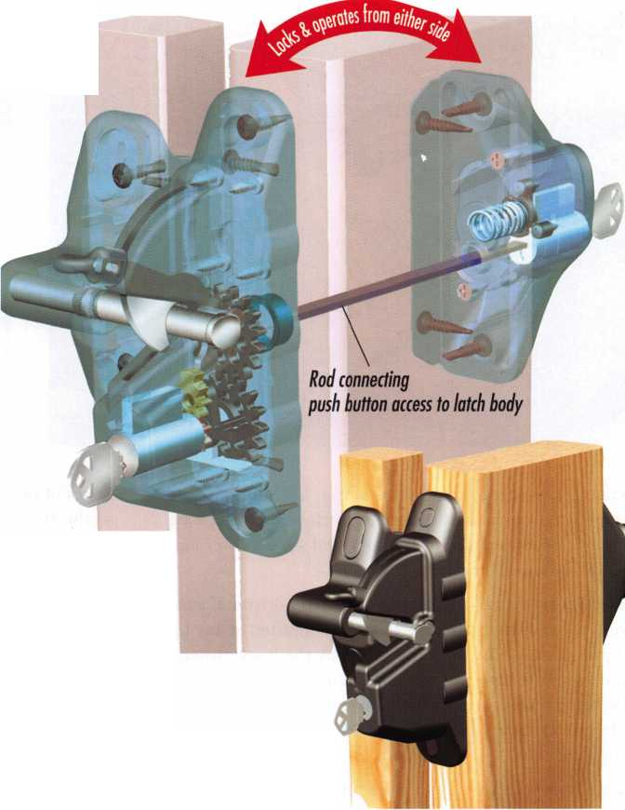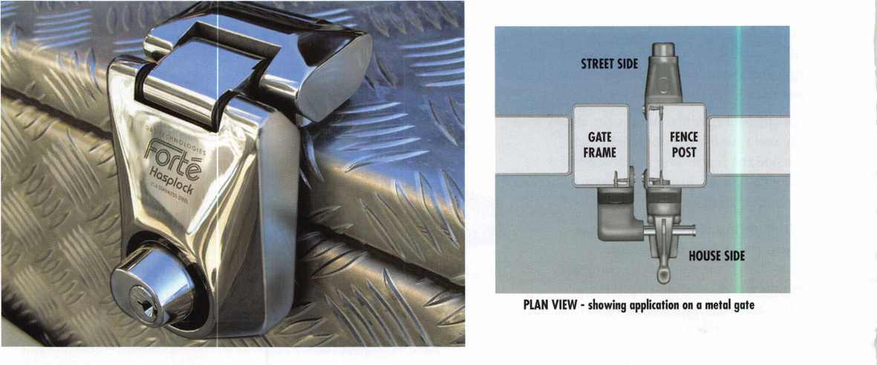

knob is first lifted the distance of the “lost motion,” and there is no mechanical resistance to closure. The release knob is not supported by a spring, and so can never fail due to spring sag or breakage.

The Magna-Latch offers unprecedented horizontal and vertical adjustment. The latch can be adjusted at any time during installation, or in the future by the homeowner, in the event the gate gets out of alignment due to children swinging on the gate, ground movement, or other causes. Only an ordinary screwdriver is needed to make these adjustments.

This latch is designed as a child safety latch rather than a security latch, so all Magna-Latches are keyed alike and not designed to be re-keyed.

Calabria said, “For a gate to latch effectively every time, it must be in proper working order. Metal hinges and latches can corrode, or be affected by paint or rust so that gates no longer latch. When gates move out of alignment, they may not self-close or latch. The Magna-Latch prevents all of these problems.

The Magna-Latch is most effectively used with Tru-Close safety gate hinges. Tru-Close hinges are molded from glass- fiber reinforced, UV-stabilized polymer. This material pro­vides strong, rust-fee hinges that won’t bind, sag or stain, and never require lubrication.

Tru-Close hinges come in regular and heavy-duty models to fit most gate sizes and all gate materials. The newly intro­duced Tru-Close DecoMold hinges are similar in appear­ance to metal decorative T-style and strap-style ornamental hinges, with none of the disadvantages of metal (rust, bind­ing, sagging and staining). Most models of Tru-Close hinges are self-closing, with an internal stainless steel spring closer.

Gates of different sizes and weights incur different loads, so the ability to adjust tension quickly is critical, especially in child safety areas. The unique, spring-loaded adjustor within most Tru-Close hinges allows instant, incremental tension adjustment using only a screwdriver. Regular mod­els have been tested to 50,000 cycles, heavy-duty models to 200,000 cycles.

Another innovative product introduced by D&D Technologies this year is the LokkBolt®. Believed to be the first lockable drop-bolt ever produced, D&D’s Lokk-Bolt provides added security for double-drive gates. Calabria said, “No longer will potential intruders be able to enter a property just by pushing hard on the gate. D&D’s new Lokk-Bolt is stylish, sturdy, and easy-to-install. It provides both privacy and security for double-drive gates.”

The Lokk-Bolt can be keyed-alike to most household doors by a locksmith. It features a 6-pin security lock and a 316- grade stainless steel drop rod, and all other components are constructed of tough, molded polymer.

“The Lokk-Bolt features a special retention ‘detent’ groove so the bolt won’t drop, drag or bend,” Calabria continues,” which means the bolt won’t grind across the driveway.”

The Lokk-Bolt comes in 18”, 24” or 36” bolt lengths, and an optional base plate is available so that drilling of the con­crete drive is unnecessary. The Lokk-Bolt is suitable for metal, wood or vinyl gates, and will provide rust-free opera­tion for life. It comes with a limited lifetime warranty.

For further information on the Forte line of stainless steel gate locks, or D&D Technologies full line of gate hardware products, call 800/716-0888, ext. 231, e-mail [info@ddtechusa.com](mailto:info@ddtechusa.com), or visit [www.ddtechusa.com](http://www.ddtechusa.com).



Keynotes • October 2003

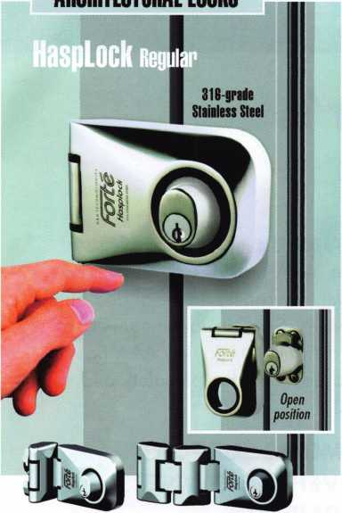

Single Hinge model Double-Hinge model

Storefront, door, goto K storage secoriQr never looked nils good

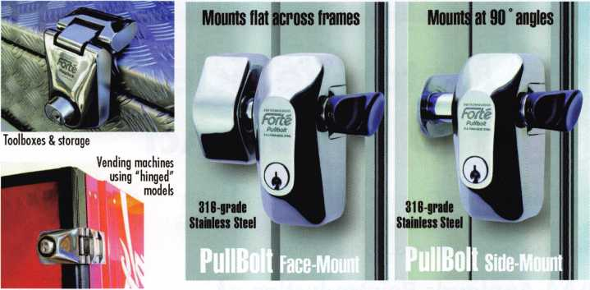

The new range of **Forte™ Stainless Steel Locks** sets new standards in quality commercial and industrial gate locking security. They are designed for all types of storefront, door, gate and storage locking, either as add-on security for existing locks or as primary locks. All locks are highly resistant to hacksawing, levering and oxyacetylene cutting.

All Forte **HaspLocks** (3 models) and **PullBolts** (2 models) use a standard 6-pin "key-in-knob" style lock cylinder which can be keyed alike, master-keyed, maison-keyed or replaced with high security systems such as Abloy, Assa, Kaba, Medeco, Mul-T-Lock, Schlage Primus...

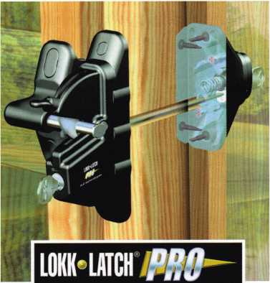

**ADJUSTABLE, SELF-CLOSING GATE HINGES**

Vertical Pull  
model

* Patented, quick tension adjust
* Tough, durable polymers
* Meets Barrier Codes
* Lifetime Warranty

Top Pull

model

**MAGNETIC SAFETY GATE LATCH**

Magnetically triggered safety Key-lockable convenience Adjusts vertically & horizontally Meets Barrier Codes Lifetime Warranty

Key-alike convenience (6-pin)  
Can be master-keyed  
Fits metal, wood & vinyl gates

Lifetime Warranty

Quality

Endorsed

Company

D&D Technologies (USA) Inc., 7731 Woodwind Drive, Huntington Beach CA 92647

Tel: (800) 716-0888 Fax:(800) 464-6400 E-mail: [gateware@ddtechusa.com](mailto:gateware@ddtechusa.com) Web: [www.ddtechusa.com](http://www.ddtechusa.com)

**Safety, Privacy & Security**

SAFETY GATE HINGES

Tension-adjustable, self-dosing hinges ideal for all types of safety gates. Tough & durable polymer construction. No rust, binding, sagging or staining!

**WORLD'S SAFEST** SATE LATCH A **PRIVACY** BATE LATCH THAT

A revolution in safety latches! Patented **OPENS & LOCKS FROM BVTH SIDESI**

technology provides super-safe latch action.

TCHDMAl

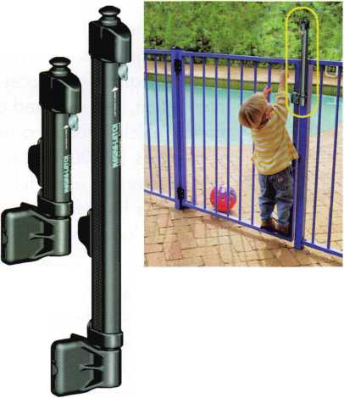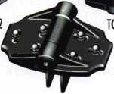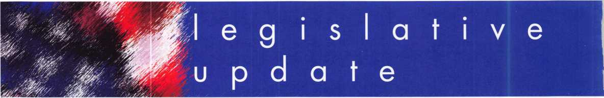

The Motor Vehicle Owner's Right to Repair Act

The Motor Vehicle Owner's Right to Repair Act Bill will be coming up for a vote shortly. It currently has 64 co-sponsors from around the nation.

AAA Applauds Reintroduction of Right to Repair Legislation Washington, D.C.

AAA, the leading provider of automotive services to North American vehicle owners, today said it will work closely with Representatives Joe Barton (R-TX) and Edolphus Towns (D-NY) to pass H.R. 2735, the "Motor Vehicle Owner's Right to Repair Act."

"AAA has been a strong supporter of this legislation for three important reasons: consumer choice; vehi­cle safety; and the right of car owners to own the information generated by their automobiles," said John Nielsen, Director of AAA Automotive.

As technology has become more advanced, service data in today's vehicles are increasingly governed by sophisticated computer systems. Some American and import automobile manufacturers are currently impeding independent repair facilities' access to and use of data generated by automobiles sold to the public, leaving consumers with no choice but to take their vehicle to a dealer.

"Having confidence in a trusted service technician and having the opportunity to seek a second opin­ion are rights every consumer should have. And why not? Both usually lead to better customer serv­ice and lower prices," said Nielsen.

The bill was first introduced during the last session of Congress, and AAA testified in support of the legislation before a Senate hearing in September 2002.

As North America's largest motoring and leisure travel organization, AAA provides its 46 million members with travel, insurance, financial and auto- motive-related services. Since its founding 100 years ago, the not-for-profit, fully tax-paying AAA has been a leader and advocate for the safety and secu­rity of all travelers.

WHY LOCKSMITHS SUPPORT THE MOTOR VEHICLE OWNERS'

RIGHT TO REPAIR ACT

Not long ago, if you lost a car key, you could pick up a replacement for a minimal cost from a lock­smith sent to your location virtually 24/7. However, with use of Immobilizer Anti Theft technology, the car owner and locksmith facilities are now at the mercy of the dealers' service departments. Many of the manufacturers use their service department monopoly and block access to needed service tools, information, and required codes to service late model vehicles. Today, a replacement key can cost as much as $2000, and many can only be made at a car dealership using full content service tools. Of course, this happens only during normal business hours at a location of their choosing.

Plus, the consumer suffers the added expense of tow­ing and risks transport damage to a secured vehicle as it is taken to the dealership. This results in added costs that are passed on to the consumer, and this does not include additional down time or trip inter­ruption costs to the consumer that experiences an after hours breakdown. Many times the loss of keys comes over the weekend when many car dealer­ships are closed, and the consumer must wait until Monday for service.

Keynotes • October 2003

The Associated Locksmiths of America, Inc. (ALOA), representing thousands of locksmiths nationwide and abroad, supports the Motor Vehicle Owners' Right to Repair Act. The legislation will require the Federal Trade Commission to prescribe and enforce rules necessary to ensure the right of a motor vehicle owner to obtain all information required for the diagnosis, service, and repair of the motor vehicle in a timely, affordable, and reliable manner. Although the bill does not specifically say what infor­mation must be provided, inherent in servicing a motor vehicle is the ability to provide key replace­ment services.

Over 90 percent of ALOA's professional locksmith members face increasing difficulties in providing service to the motoring public due to the unavailabil­ity of this information from the car manufacturers. Currently, service information on most or all BMW, Infiniti, Jaguar, Mazda, Mercedes, Volkswagen and Volvo autos is held exclusively by the car manufac­turers and remains unavailable to the professional locksmith, therefore forcing the customer to return to the dealership for service.

The Motor Vehicle Owners' Right to Repair Act seeks to remedy this situation by ensuring the motor vehi­cle owners (or their trusted locksmith) their right to the information necessary to service his or her vehi­cle, at a time and place of the owners choosing.

The legislation does this without requiring car manufacturers to divulge proprietary information or trade secrets.

Recent Consumer Complaints

* A motorist in Fargo, ND, lost the keys to his car and had to have the car towed to Bismarck (200 miles away) to the dealership because a lock­smith could not originate a key.
* A customer in Northern California lost her keys in the snow. The locksmith had no key codes to make a new key, so the cylinder had to be removed to start the car. Now the customer has to replace the cylinder!
* When a motorist in Tampa, FL, needed VW roadside assistance to replace her lost key on Thanksgiving day, they told her that no one was available. The locksmith could not help her because Volkswagen does not make their key codes available, and she had to have the car towed and wait for her dealership to open the next day!
* A customer in West Palm Beach, FL, lost all keys to her Toyota and had to have the transponder module replaced an all the locks replaced by the dealer at a cost of $ 1 300!
* Twenty-five senior citizens were stranded in the rain in Bigfork, MT, because roadside assistance would not release key codes to the locksmith.

The van was not serviced until the next day!

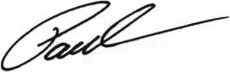

Paul Kanitra

Government Relations Manager



SAFE CORPORATION

MANUFACTURES OF QUALITY DEPOSITORY SAFES AND CHESTS

DISTRIBUTING FROM WAREHOUSES IN

* LOS ANGLES, CA
* CHICAGO, IL
* GLASSBORO, NJ

A & B is now a stocking distributor

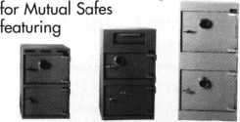

AB-4-30-3S AB-9-2 WS 10-2

Chose from over 75 models in stock

We ship your order within

24 hours

See us

*of [www.a-bsafecorp.com](http://www.a-bsafecorp.com)*800-253-1267  
Fox 856-863-1208

CALL FOR YOUR  
CATALOG TODAY



Keynotes • October 2003

EMPLOYMENT

CENTURION SAFE AND LOCK, INC.

of Cantonsville MD, a thriving community of the out­skirts of Baltimore is forced to close its doors, due to the incapacitation caused by cancer and multiple ret- lated issues of owner, Stephen J. Brown, CML (age 46) (ALOA #8132). Having been unable to generate the necessary funds to keep the more vital bills current, with walk-in traffic only, and the outside road calls virtually impossible for Steve to handle, the need for immediate liquidation has become URGENT. A locksmith shop has occupied this rental storefront location for 40 + years, with Centurion serving the community faithfully since 1985. Steve would prefer to sell his turnkey opportunity in tact and in its entire­ty, but failing to meet his 95K asking price will sell in part if it becomes a final option. The business includes (2) equipped service vans, a 1995 E250 and a 1988 Ford One-ton extended. The fully equipped shop includes all inventory, tools, computer, office supplies, furniture, sidewinder high security key machine, 2 HPC 1 200's, Framon #2 and far too much to list here. To speak to Steve, please call 410- 747-5625. -Written for Steve by Gary M Leibman, CRL-ALOA# 17234

EXPERIENCED LOCKSMITH WANTED

at established business located in beautiful Marin County, 25 miles from San Francisco. Good pay, health plan, paid absence and pension plan avail­able. Neat appearance and good driving record required. Send resume, refs, to Novato Lock. 7395 Redwood Blvd Novato, CA 94945 or call 415-892-0050

SECURITY TECHNICIAN

Looking for experienced, motivated, hardworking technicians. And team players. Great income poten­tial. Don't delay, send resume today.

Liberty Lock and Safe 5470 W. Sahara Ave.

Las Vegas, NV 89146

Fax 702/876-5470, or [www.libertylock.com](http://www.libertylock.com)

BUSINESS FOR SALE

LOCKSMITH FRANCHISE AVAILABLE

Low cost, complete training, national Franchise call (925) 260-7373 [www.SpeedyLocksmiths.com](http://www.SpeedyLocksmiths.com) . Business For Sale

NORTHERN CALIFORNIA, SAN FRANCISCO BAY AREA, GREAT SALES, FOR MORE INFO CALL (925)260-7373

BUSINESS FOR SALE

A small, quite successful business for sale in south Orange County, California. Three Rytan machines, three HPC code machines, HPC code books, coding program, tools for "luxu­ry" vehicle lockouts - all parts, tools and sup­plies to keep two trucks on the road full time. One truck on the road provides $10-1 IK per month. Truck, which is the Ford F250 van with advertising signage, built-in work areas and cabinetry - can be part of the package or pur­chased separately. Low operating costs after 10 years of building the business. Advertising expenses 10 years ago? $4K per month. Now we pay a fifth of that. This is a nice set-up for someone to step in and take over. Existing accounts (which bring in about $8200/month include three in property management and eight auto dealerships. Well work to set you up with our existing accounts. All reasonable offers will be considered. Call 949/370- 9619, or fax 949/458-1733.

WANTED TO BUY/SELL

FOR SALE

Owner retiring. Lift a Load trailer. 10,000 lbs. Capacity. Excellent condition. Sonny Lee. 770/920-8019.

FOR SALE

Original Schlage blanks in 5-pin EF keyway or 6-pin in CE, EF, FG or G keyway at $12.50 per box of 50. Contact George Thomas at 21 8-724-3416 or write to 825 Woodlandd Ave., Duluth MN 55812-2168

FOR SALE

Overstock, New Von Duprin 33NL-OP, 33EO, E99K, 3347EO, 9947EO, CD3347TL, EPT-10, Von Duprin electric strike 6211,6233. Rixson mag hold 980,997 Locknetics 505. Please call for price. Kevin at 915-553-3145, or e-mail [reddog2501@excite.com](mailto:reddog2501@excite.com).

WHOLESALE SAFE DEPOSIT LOCKS Allied, Diebold, Herrin, Hall & Mavin, llco, Lefabure, Mosler, Precission, S&G, Security Corp., Yale. Locks from early 1900s to current. Call or email for lock type and pricing sheet. Quantity discounts. Call WBI at (954)484-2404 or email: [sales@wbi.us](mailto:sales@wbi.us)

CLASS

Ohio Valley chapter of ALOA is holding a safe open­ing class on September 27/28 in Dayton, Ohio. This is an hands-on class and if you have any safes you'd like opened bring them with you. Thanks to help from Lockmasters, all the proceeds from this class will go towards a fundraiser for sending locksmiths to the 2004 ALOA convention and classes. The fee for this two day class is $110.00 for ALOA and POLA mem­bers and $150.00 for all others. Please contact Mehdi at (937) 294-4241 for further information. Class is limited to 25 people, so hurry!

Classified Advertising Policy

Classified advertising space is provided free of charge to ALOA members, and fora fee of $.60 per word, $15 minimum for non-members. Classified ads may be used to advertise used  
merchandise and overstocked items for sale, "wanted to buy" items, business opportunities, employment opportunities/positions wanted and the like. Members or non-members wishing to  
advertise services or new merchandise for sale may purchase a "Commercial Classified Ad," for a fee of $1.30 per word, with a minimum of $40. Each ad will run for two issues. For  
blind boxes there is a $5 charge to members and non-members. All ads must be submitted in writing to the ALOA office by the fifteenth of the month, two months prior to issue date. Send  
to Keynotes Classifieds, 3003 Live Oak St., Dallas TX 75204-6186. ALOA reserves the right to refuse any classified advertisement that it deems inappropriate according to the stated pur-  
pose of the classified advertising section.

Keynotes • October 2003



TURfltO

WHOLESALE SERVICE

**800**-**848-9790**

**One Call Gets You...**

**Amsec, Gardall  
Hayman, Meilink  
Victor, Winchester**

**Plus Free Delivery  
From America's  
Largest Inventory  
of Safes.**

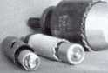

Hole **Saw**

Alignment

Guides

No More Plywood, **”C"** Clamps, or Jigs  
Needed to Over Bore Existing Holes

* Our Guides let you over bore existing holes  
  that meas. 5/8", 3/4” & 1-1/2” diameter
* They work on wood as well as metal
* Itoo small sizes ideal for desks and cabinets
* Purchase in sets or individually
* Visa, MC, Amex, Discover
* MONEY-BACK GUARANTEE

**Tri-City Lock Company**

Daniel **D.** Mello, Owner-Locksmith  
Groveland, CA

209 962 4692 • 209 962 4910 FAX E-mail: [slmello@mlode.com](mailto:slmello@mlode.com) **[www.tricityjock.com](http://www.tricityjock.com)**

**THE HINGE DOCTOR**

**by GKL Products**

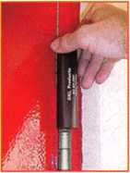

**HA1 For  
Standard**

**Commercial**

**4-1/2" x 4-1/2'**

**Butt Hinges**

**HA2**

***"The HULK"***

**For Residential Hinges**

**COMING IN  
SEPTEMBER**

**HA3**

**For Ball- Bearing**

**Commercial Hinges**

**The Hinge Doctor is a great way to repair those sagging metal  
doors. Slip the tool over the hinge and open the door an inch**

**or two past the point where the tool binds against the  
hinge, remove the tool and check the door,**

**which should now be working properly.**

**If you're a locksmith these tools**

**will turn a profit the 1st time you**

**use them!  
Uses - schools, hospitals,**

**commercial buildings, storefronts**

**with butt hinges, office doors, new**

**construction, door alignment, sagging**

**doors, jail cells, anywhere there are  
commercial grade hinges.**

**HA4**

**For Prison**

**& Institutional**

**Hinges &**

**Spring Hinges**

US Patent **#6450003**

**[www.hingedoctor.com](http://www.hingedoctor.com)**

**800-924-5397**

Over

10,000

Satisfied

Customers

Keynotes • October 2003

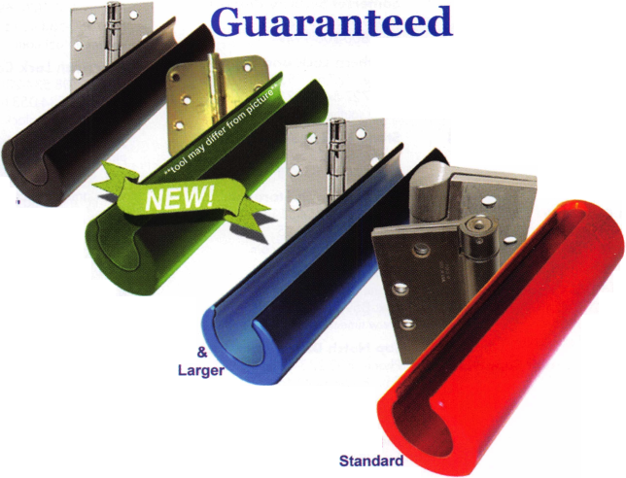

Distributor

ADI Inc

Phone: 631-692-1000 Fax: 631-692-301 1

Accredited Lock Supply Co

Phone: 201-865-5015 Fax: 201-865-0030 [www.acclock.com](http://www.acclock.com)

Ace Lock & Security Supply

Phone: 908-688-7666 Fax: 908-688-2442 [www.acelock.com](http://www.acelock.com)

Andrews Wholesale Lock Supply

Phone: 717-272-7422 Fax: 717-274-8659 [www.andrewslock.com](http://www.andrewslock.com)

Boyle & Chase Inc

Phone: 800-325-2530 Fax: 800-205-3500 [www.boyleandchase.com](http://www.boyleandchase.com)

Chinrose International

Phone: 503-357-7553 Fax: 503-357-5522 [www.chinrose.com](http://www.chinrose.com)

Clark Security Products

Phone: 800-854-2088 Fax: 619-974-5284 [www.clarksecurity.com](http://www.clarksecurity.com)

Cook's Building Specialties

Phone: 505-883-5701 Fax: 505-883-5704

Dire's Lock & Key Company

Phone: 303-294-0176 Fax: 303-294-0198

Direct Security Supply, Inc.

Phone: 800-252-5757 Fax: 800-452-8600

Doyle Security Products

Phone: 800-333-6953 Fax: 612-521-0166 [www.doylesecurity.com](http://www.doylesecurity.com)

Dugmore and Duncan, Inc.

Phone: 888-384-6673 Fax: 888-329-3846

E. L. Reinhardt Co., Inc.

Phone: 800-328-1311 Fax: 651-481-0166 [www.elreinhardt.com](http://www.elreinhardt.com)

Ewert Wholesale Hardware

Phone: 800-451-0200 Fax: 708-597-0881

Fairway Supply, Inc.

Phone: 214-350-0021 Fax: 214-352-4299 [www.fairwaysupply.com](http://www.fairwaysupply.com)

Foley-Belsaw Company

Phone: 800-821-3452 Fax: 816-483-5010 [www.foley-belsaw.com](http://www.foley-belsaw.com)

Fried Brothers Inc.

Phone: 800-523-2924 Fax: 215-592-1255 [www.fbisecurity.com](http://www.fbisecurity.com)

£

|  |  |  |  |  |
| --- | --- | --- | --- | --- |
| if' 1  ■PL 4  9 t | a | s s o c | i a 1 | t e |
| w |  | m e m b | e r s |  |

H L Flake Co

Phone: 800-231-4105 Fax: 713-926-3399 [www.hlflake.com](http://www.hlflake.com)

H.S. & S. Wholesale Distrib.

Phone: 313-342-6777 Fax: 313-342-7580

Hans Johnsen Company

Phone: 214-879-1550 Fax: 214-879-1530 [www.hjc.com](http://www.hjc.com)

Hardware Agencies, Ltd.

Phone: 416-462-1921 [www.hardwareagencies.com](http://www.hardwareagencies.com)

IDN Incorporated

Phone: 817-421-5470 Fax: 817-421-5468 [www.idn-inc.com](http://www.idn-inc.com)

Intermountain Lock & Supply

Phone: 800-453-5386 Fax: 801-485-7205 [www.intermountainlock.com](http://www.intermountainlock.com)

Jo Van Distributors

Phone: 416-752-2238 Fax: 416-752-7282 [www.jovanlock.com](http://www.jovanlock.com)

KeylessRide

Phone: 877-619-3136 Fax: 409-216-5058 [www.keylessride.com](http://www.keylessride.com)

Lockmasters, Inc.

Phone: 859-885-6041 Fax: 859-885-7093 [www.lockmasters.com](http://www.lockmasters.com)

Locks Company

Phone: 800-288-0801 Fax: 305-949-3619

Locksmith Ledger International

Phone: 770-886-0800 Fax: 770-889-7703 [www.lledger.com](http://www.lledger.com)

M. Zion Company

Phone: 212-349-8677 Fax: 212-964-0495 [www.mzion.com](http://www.mzion.com)

McDonald Dash Locksmith Supp

Phone: 800-238-7541 Fax: 901-366-0005 [www.mcdonalddash.com](http://www.mcdonalddash.com)

McManus Locksmith Supply, In

Phone: 704-333-9112 Fax: 704-332-8664

Monaco Lock Co.

Phone: 800-526-6094 Fax: 800-845-5625 [www.monacolock.com](http://www.monacolock.com)

Omaha Wholesale Hardware

Phone: 800-238-4566 Fax: 402-444-1664 [www.omahawh.com](http://www.omahawh.com)

Phoenix Safe International LLC

Phone: 765-483-0954 Fax: 765-483-0962 [www.phoenixsafeusa.com](http://www.phoenixsafeusa.com)

Professional Business Products

Phone: 248-360-3979

Fax: 248-360-3982

[www.professionalbusinessproducts](http://www.professionalbusinessproducts).

RA-Lock Company

Phone: 972-775-6301 Fax: 972-775-6316 [www.ralock.com](http://www.ralock.com)

S J Hope Products

Phone: 702-260-7645 Fax: 702-837-1465

SNA Inc.

Phone: 678-206-0381 Fax: 678-206-0382 [www.sungil-safe.com](http://www.sungil-safe.com)

SecureRite.Com

Phone: 800-241-3930 Fax: 858-974-5269 [www.SecureRite.Corn](http://www.SecureRite.Corn)

Security House

Phone: 905-669-5300 Fax: 905-660-6313 [www.securityhouselock.com](http://www.securityhouselock.com)

Security Lock Distributors

Phone: 800-847-5625 Fax: 800-878-6400 [www.securadealer.com](http://www.securadealer.com)

Sentry Security Fasteners

Phone: 309-693-2800 Fax: 800-693-2872

Somerset Security Products

Phone: 800-881-5206 Fax: 800-206-9949

Southern Lock and Supply Co.

Phone: 727-541-5536 Fax: 727-544-8278 [www.southernlock.com](http://www.southernlock.com)

Stone & Berg Wholesale

Phone: 800-225-7405 Fax: 800-535-5625

The Locksmith Store Inc.

Phone: 847-364-5111 Fax: 847-364-5125 [www.locksmithstore.com](http://www.locksmithstore.com)

Timemaster Inc

Phone: 859-259-1 878 Fax: 859-255-0298 [www.time-master.com](http://www.time-master.com)

Top Notch Distributors, Inc.

Phone: 800-233-4210 Fax: 800-854-4146 www.4topnotch .com

Turn 10 Wholesale

Phone: 800-848-9790 Fax: 800-391-4553

U.S. Lock Corp.

Phone: 800-925-5000 Fax: 800-338-5625 [www.uslock.com](http://www.uslock.com)

Wilco Supply

Phone: 800-745-5450 Fax: 510-653-5397 [www.wilcosupply.com](http://www.wilcosupply.com)

Manufacturer

A & B Safe Corporation

Phone: 800-253-1267 Fax: 856-863-1208 [www.a-bsafecorp.com](http://www.a-bsafecorp.com)

ABUS Lock Company

Phone: 800-352-2287 Fax: 602-516-9934 [www.abus.com](http://www.abus.com)

Abloy Door Security

Phone: 800-465-5761 Fax: 514-335-0430 [www.abloy.com](http://www.abloy.com)

Adams Rite Mfg Company

Phone: 800-872-3267 Fax: 800-232-7329 [www.adamsrite.com](http://www.adamsrite.com)

Adesco Safe Mfg. Company

Phone: 800-694-9340 Fax: 562-408-6427 [www.adesco.com](http://www.adesco.com)

Adrian Steel Company

Phone: 800-677-2726 Fax: 517-265-5834 [www.adriansteel.com](http://www.adriansteel.com)

Alarm Lock Systems Inc.

Phone: 800-252-5625 Fax: 516-789-3383 [www.alarmlock.com](http://www.alarmlock.com)

All Five Tool Company, Inc.

Phone: 860-583-1691 Fax: 860-583-4516 [www.all5tool.com](http://www.all5tool.com)

American Lock Company

Phone: 708-534-2000 Fax: 708-534-0531 [www.armericanlock.com](http://www.armericanlock.com)

American Security Products

Phone: 909-685-9680X1083 Fax: 909-685-9685 [www.amsecusa.com](http://www.amsecusa.com)

BWD Automotive

Phone: 334-872-6524 Fax: 334-874-6011 [www.bwdautomotive.com](http://www.bwdautomotive.com)

Baldwin Hardware

Phone: 610-796-4012 Fax: 610-796-4493 [www.baldwinhardware.com](http://www.baldwinhardware.com)

Be-Tech Security Systems Ltd

Phone: 852-231-67447 www. be-tec h. co m. h k

Bianchi USA, Inc.

Phone: 800-891-2118 Fax: 216-803-0202

Buddy Products

Phone: 800-886-8688 Fax: 312-733-8356 [www.buddyproducts.com](http://www.buddyproducts.com)

CCL Security Products

Phone: 800-733-8588 Fax: 847-537-1800

COMPX Security Products

Phone: 864-297-6655 Fax: 864-297-9987 [www.nclnet.com](http://www.nclnet.com)

**2**

Keynotes • October 2003

|  |  |  |
| --- | --- | --- |
| a | s s o c i a 1 | t e |
|  | members |  |

Curtis Industries, A Barnes Distr

Phone: 800-555-5397 Fax: 800-867-6020 [www.curtisindustries.com](http://www.curtisindustries.com)

D&D Technologies (USA), Inc

Phone: 714-677-1300X292 Fax: 714-677-1299 [www.ddtechusa.com](http://www.ddtechusa.com)

DETEX Corporation

Phone: 800-729-3839 Fax: 830-620-671 1 [www.detex.com](http://www.detex.com)

DORM A Architectural Hardware

Phone: 717-336-3881 Fax: 717-336-3500 [www.dorma-usa.com](http://www.dorma-usa.com)

Datakey Electronics

Phone: 800-328-8828 Fax: 866-289-4212 [www.datakeyelectrnics.com](http://www.datakeyelectrnics.com)

Don-Jo Manufacturing, Inc.

Phone: 978-422-3213 Fax: 978-422-3467 [www.don-jo.com](http://www.don-jo.com)

Door Controls International

Phone: 800-742-3634 Fax: 800-742-0410 [www.doorcontrols.com](http://www.doorcontrols.com)

ESP Lock Products Inc.

Phone: 978-562-3481 Fax: 978-562-9859

FireKing Security Products

Phone: 800-457-2424 Fax: 800-896-6606 [www.fireking.com](http://www.fireking.com)

HES, Inc

Phone: 623-582-4626 Fax: 623-582-4641 [www.hesinnovations.com](http://www.hesinnovations.com)

HPC, Inc.

Phone: 847-671-6280 Fax: 847-671-6343 [www.hpcworld.com](http://www.hpcworld.com)

HY-KO Products Co.

Phone: 440-232-8223X3095 Fax: 440-232-8227

Hongtai Lock Co Ltd

Phone: 137-238-1414 Fax: 208-793-3856

INTELLIKEY Corp.

Phone: 800-226-0703 Fax: 321-724-0811 www. i ntel I i key. com

Jet Hardware Mfg., Co.

Phone: 718-257-9600 Fax: 718-257-0973 [www.jetkeys.com](http://www.jetkeys.com)

KABA High Security Locks

Phone: 860-621-3601 Fax: 860-621-9727 [www.kabausa.com](http://www.kabausa.com)

KABA ILCO Corp.

Phone: 252-446-3321 Fax: 252-446-4702 [www.kaba-ilco.com](http://www.kaba-ilco.com)

KEY-BAK/West Coast Chain Mfg

Phone: 909-923-7800 Fax: 909-923-0024 [www.keybak.com](http://www.keybak.com)

Keri Systems Inc

Phone: 408-451-2520 Fax: 408-441-0309 [www.kerisys.com](http://www.kerisys.com)

Knaack Manufacturing Co.

Phone: 800-456-7865 Fax: 815-459-9097 www. weatherg ua rd .com

LAB Security

Phone: 800-243-8242 Fax: 860-583-7838 [www.labpins.com](http://www.labpins.com)

LCN Closers/Div of Ingersoll

Phone: 815-875-3311 Fax: 815-879-1497 [www.lcnclosers.com](http://www.lcnclosers.com)

La Gard Inc.

Phone: 310-325-5670 Fax: 310-325-5615 [www.lagard.com](http://www.lagard.com)

Lock America, Inc. Dba L.A.I. Gro

Phone: 714-373-2993 Fax: 714-373-2998 [www.laigroup.com](http://www.laigroup.com)

Lucky Line Products, Inc.

Phone: 858-549-6699 Fax: 858-549-3241 [www.luckyline.com](http://www.luckyline.com)

M.A.G. Security

Phone: 714-891-5100 Fax: 714-892-6845 [www.magsecurity.com](http://www.magsecurity.com)

MARKS, U.S.A.

Phone: 516-225-5400 Fax: 516-225-6136 [www.marksusa.com](http://www.marksusa.com)

MARRAY ENTERPRISES

Phone: 408-970-0213 Fax: 408-970-8767 [www.marray.com](http://www.marray.com)

MCS Communication Systems

Phone: 450-444-2040X225 Fax: 450-444-4856 [www.mcscommunication.com](http://www.mcscommunication.com)

MMD, Inc.

Phone: 865-428-3611 Fax: 865-453-4136

MUL-T-LOCK USA, Inc

Phone: 800-562-3511 Fax: 973-778-4007 [www.mul-t-lock.com](http://www.mul-t-lock.com)

Master Lock Company

Phone: 414-444-2800 Fax: 414-444-0322 [www.masterlock.com](http://www.masterlock.com)

Medeco Security Locks

Phone: 540-380-5000 Fax: 540-380-5010 [www.medeco.com](http://www.medeco.com)

Mustang Company

Phone: 574-674-0053 Fax: 574-675-9603

NKL Industries Inc

Phone: 800-528-9900 Fax: 757-485-0271 [www.nklindustries.com/products_NK](http://www.nklindustries.com/products_NK)

OSI Security Devices

Phone: 619-628-1000 Fax: 619-628-1001 [www.omnilock.com](http://www.omnilock.com)

Pro Steel

Phone: 801-373-2385 Fax: 801-373-2399 [www.prosteel.us](http://www.prosteel.us)

ROFU International Corp

Phone: 800-255-7638 Fax: 253-922-1728 [www.rofu.com](http://www.rofu.com)

Rutherford Controls Int'l Co

Phone: 757-427-1230 Fax: 757-427-9549 [www.rutherfordcontrols.com](http://www.rutherfordcontrols.com)

STRATTEC Security Corp.

Phone: 414-247-3415 Fax: 414-247-3692 [www.strattec.com](http://www.strattec.com)

Sargent & Greenleaf, Inc.

Phone: 859-885-9411 Fax: 859-885-3063 [www.sargentandgreenleaf.com](http://www.sargentandgreenleaf.com)

Sargent Manufacturing Co

Phone: 203-562-2151 Fax: 203-776-5992 [www.sargentlock.com](http://www.sargentlock.com)

Schlage Lock Co

Phone: 719-264-5300 Fax: 719-264-5382 [www.schlagelock.com](http://www.schlagelock.com)

Schwab Corp

Phone: 765-447-9470 Fax: 765-447-8278 [www.schwabcorp.com](http://www.schwabcorp.com)

Secure-UR-Home

Phone: 905-771-7300 Fax: 905-771-7304

Securitron Magnalock Corp.

Phone: 775-355-5625 Fax: 775-355-5636 [www.securitron.com](http://www.securitron.com)

Security Door Controls

Phone: 805-494-0622 Fax: 805-494-8861 [www.sdcsecurity.com](http://www.sdcsecurity.com)

Security Solutions

Phone: 405-376-1600 Fax: 405-376-6870 [www.securitysolutions-usa.com](http://www.securitysolutions-usa.com)

Sully Tools Inc

Phone: 703-689-3416 Fax: 703-787-0869 [www.sullytools.com](http://www.sullytools.com)

Sun Safes Manufacturing Co.

Phone: 823-194-59300 Fax: 823-194-59400 [www.eaglesafes.com](http://www.eaglesafes.com)

Taylor Security & Lock

Phone: 301-948-7670 Fax: 301-948-1029 [www.taylorsecurity.com](http://www.taylorsecurity.com)

Taymor Industries, Inc.

Phone: 800-388-9887 Fax: 800-288-8133

Townsteel, Inc.

Phone: 626-858-5080 Fax: 626-858-3393

Trine Access Technology

Phone: 718-829-2332 Fax: 718-829-6405 [www.trineonline.com](http://www.trineonline.com)

Victor E-lok, Inc

Phone: 949-916-1200 Fax: 949-916-1300 [www.victorelok.com](http://www.victorelok.com)

Videx Inc

Phone: 541-758-0521 Fax: 541-752-5285 [www.videx.com](http://www.videx.com)

W-LOK Corporation

Phone: 616-355-4015 Fax: 616-355-4295 [www.wlokcorp.com](http://www.wlokcorp.com)

YSG Door Security Consultants, In

Phone: 800-438-1951 Fax: 800-338-0965

Service Organization

1 -800 Locksmith 1994 Inc

Phone: 800-562-5764 Fax: 718-236-4504 WWW. 1800locksmith.net

Allstate Insurance Company

Phone: 800-859-0247 Fax: 847-326-7509 [www.allstate.com](http://www.allstate.com)

Cross Country Automotive Svs.

Phone: 800-541-2262 Fax: 781-393-0256 [www.argosi.com](http://www.argosi.com)

Emergency Road Service Inc

Phone: 888-839-5386 Fax: 678-277-8105

Massglass & Door Service

Phone: 888-742-8837 Fax: 805-497-2255 [www.massglass.com](http://www.massglass.com)

The National Locksmith

Phone: 630-837-2044 Fax: 630-837-1210 [www.thenationallocksmith.com](http://www.thenationallocksmith.com)

The Security Professionals

Phone: 866-486-1938

Fax: 856-486-0401

[www.thesecurityprofessionals.com](http://www.thesecurityprofessionals.com)

Webster Safe & Lock Co., Inc

Phone: 901-332-2911 Fax: 901-332-2878

[www.webstersinc.com](http://www.webstersinc.com)

Keynotes • October 2003

back page

About the Authors

Raymond D'Adamo, CML, is originally from Hoboken, NJ. In 1973 he graduated Rutgers University and in 1977 he began locksmithing in Boulder Colorado. In 1981 he began writing automotive lock- smithing technical articles for locksmith publications, and began instructing automotive locksmithing courses at trade association meet­ings and conventions. In 1983 he and his wife Tina D'Adamo moved to Fort Collins, CO and opened Fort Security Center. Since then their business, TRI-CITY Security, has grown to two additional facilities in Greeley and Loveland, CO. Ray is an active member of ALOA since 1978 and continues to contribute to the education of locksmiths all over the world.

Ann McCrady, CPL, is a communications manager for Medeco Security Locks, Inc.

Greg Perry, CML, CPS, has been in the locksmith industry for 20 years. He's spent half of that time as a field technician for Security Engineering in Ridgecrest, CA. Greg is also a past president of the Desert Counties Chapter of the California Locksmiths Association. He has also won the 2002 Keynotes Author of the Year Award. You can e-mail him at [glmperry@iwvisp.com](mailto:glmperry@iwvisp.com).

Maureen Williams is the Manager of Public Relations for D&D Technologies (USA), Inc.

|  |  |  |  |
| --- | --- | --- | --- |
| r |  |  |  |
| DHI | Inside Front | D&D Forte | ...37 |
| Accurate | 3 | Hinge Doctor | .41 |
| Assa | 9 | Tri-City Lock Co | .41 |
| Videx | 1 1 | Turn 10 | ...41 |
| Fox Valley Technical  College 1 1 | | Professional  Business  Products Back Page | |
| A&B Safe .39, Back Page | | Medeco...Inside Back Cover | |
| OSI | 31 | Hickok Back Cover | |
|  | Ad Index | |  |
| L |  |  | 1 |



**SAFE CORPORATION**

Viking Stainless

Fire & Burglary Protection  
State of the Art Composite Fill

Strong • Functional • Attractive

Available in 10 sizes  
to Fit Every Need

See us at [www.a-bsafecorp.com](http://www.a-bsafecorp.com)

1-800-253-1267

Fax 856-863-1208

CALL FOR YOUR CATALOG TODAY



Advertise with Weatherproof Safety Labels!

Lockout your  
competition

by placing your  
calling card on  
every door you  
service! Keep

your name in front  
of every customer  
with these Durable,  
Affordable Labels  
Call & Order Today  
1-800-355-6322

(Actual Label Size 1 1/2x4 1/2)

see you lia, Lflsvegfls aloa Expo Booth goo

Professional Business Products

ALOA Associate Member

Check out our competitive prices on Invoices with two color ALOA  
logo, Repair Tags/Claim Checks, Business Cards, Door Hangers,  
Shirts, Hats, Pens, Key Tags, Magnets.

[www.professionalbusinessproducts.com](http://www.professionalbusinessproducts.com)

§

Keynotes • October 2003

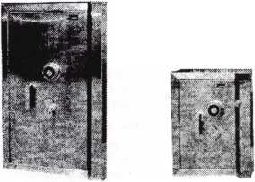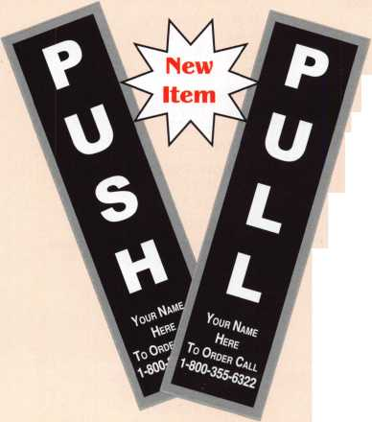

**MEDECO RECENTLY GOT CALLED ON THE CARPET. THE RED CARPET.**

**medeco DEBUTS with rave reviews, and record-breaking sales.**

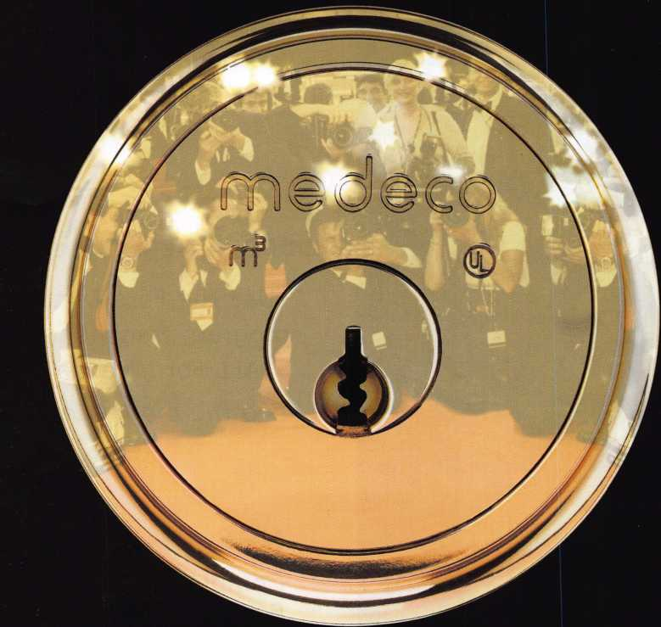

**WE’D LIKE TO TAKE THIS OPPORTUNITY TO THANK ALL THOSE WHO MADE ITS SUCCESS POSSIBLE: Distributors and locksmiths who were amazed we could create a patented locking system better than Biaxial.**

**The competition who thought we’d let up, content to be number one.**

**The customers who demanded the same physical strength and key control but with expanded master key capacity.**

**The Medeco engineers who believed two locking mechanisms weren’t enough.**

**To all of you who gave us suggestions, we say thanks. We couldn’t have done it without you.**

**medeco**

**P.O. Box 3075, Salem, Virginia 24153-0330 I Customer Service: 1-800-839-3157 I [www.medeco.com](http://www.medeco.com) high security locks**

© 2003, Medeco Security Locks, Inc.

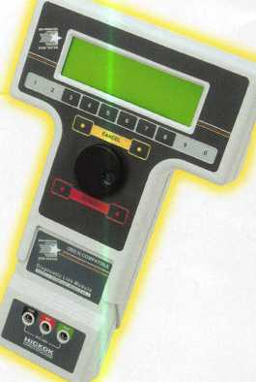

**Your Key to Unlocking**1 **Ford/Mazda Transponder**

**Hi -jW. -** HHfh  **•». . - ... a* - aMa ®** ^atM'

ife I)

**Profits.**

y **You're never on your own.,**

**Toll Free Tech Support**

8008LA New Generation STAR

Use the Ford factory tool to  
program transponder keys for  
ALL Ford/Mazda vehicles.

Keep the money in your pocket!

Say "YES" to  
$100 phone calls

**1**-**800**-**342-5080**

for more information visit

**[www.hickok-inc.com](http://www.hickok-inc.com)**

"I've lost my Taurus

can you make a new

How much of your money  
have you sent to the  
local Ford dealer?

NGS

Complete

Ford/Mazda

transponder

coverage

PLUS the

ability to clear ALL

Diagnostic

Service Codes

